ARMIGO: GAMIFIED VR-BASED THERAPY SYSTEM FOR UPPER LIMB
REHABILITATION IN CHILDREN WITH HEMIPLEGIA

Shoulder-Based Movement Tracking, LSTM Classification,
and VR Therapy Component

A dissertation submitted in partial fulfilment of the requirements for the
Bachelor of Science (Hons) in Information Technology
Specializing in Software Engineering

By

WICKRAMASURENDRA K.D.A.D
IT22115720

Supervisor: Mr. Didula Chamara Thanaweera Arachchi
Co-Supervisor: Mr. Eishan Weerasinghe

Department of Information Technology
Sri Lanka Institute of Information Technology
Sri Lanka

August 2025

Declaration of the Candidate and Supervisor
I declare that this is my own work and this dissertation does not incorporate without acknowledgment any material previously submitted for a degree or diploma in any other university or Institute of higher learning and to the best of my knowledge and belief it does not contain any material previously published or written by another person except where the acknowledgment is made in the text.
Also, I hereby grant to Sri Lanka Institute of Information Technology, the non-exclusive right to reproduce and distribute my dissertation, in whole or in part in print, electronic or other medium. I retain the right to use this content in whole or part in future works (such as articles or books).

Name | Student ID | Signature | Date
Wickramasurendra K.D.A.D | IT22115720

The supervisor certifies that the above candidate is carrying out research for the undergraduate Dissertation under my supervision.

……………………………………………………… ………………………………
Signature of the Supervisor Date

……………………………………………………… ………………………………
Signature of the Co-Supervisor Date

Abstract
Hemiplegia in children, predominantly caused by perinatal stroke or cerebral palsy, results in unilateral upper limb motor impairment that profoundly restricts the performance of activities of daily living. The shoulder joint is the proximal fulcrum of all upper limb movement, and its therapeutic rehabilitation is fundamental to restoring functional arm use in hemiplegic children. Traditional physiotherapy programmes are effective but suffer from poor adherence owing to their repetitive and monotonous nature, limited accessibility in low-resource settings such as Sri Lanka, and high associated costs. These barriers create an urgent need for innovative, engaging, and affordable rehabilitation technologies designed specifically for the paediatric population.
This dissertation presents the design, development, and evaluation of the shoulder-based wearable movement tracking, LSTM classification, and VR therapy module within the ArmiGo system - a gamified Virtual Reality rehabilitation platform for children with hemiplegia. The shoulder wearable device integrates an MPU-9250 nine-axis Inertial Measurement Unit (IMU) sensor with an ESP32 microcontroller, mounted on a custom elastic shoulder band. The ESP32 firmware, developed using the Arduino development environment, applies a Quaternion Kalman Filter to raw DMP quaternion outputs and transmits filtered sensor data over WiFi using the UDP protocol. A C# Windows middleware application (GyroSensorReceiver) receives raw sensor data, applies session-based quaternion calibration and axis remapping, and forwards processed quaternion data to the Unreal Engine VR game environment via a local UDP socket connection.
A Long Short-Term Memory (LSTM) recurrent neural network was trained on shoulder kinematic data collected from both healthy children at Mahinda College, Kurunegala, and hemiplegic paediatric patients at the Department of Paediatric Physiotherapy, Sirimavo Bandaranayake Specialised Children's Hospital, Peradeniya. The model classifies six therapeutic shoulder movement classes — Abduction, Adduction, Circumduction, Extension, Flexion, and Steady — achieving per-class accuracies ranging from 66.7% for Abduction to 100% for Flexion and Steady, with an overall average classification accuracy of approximately 83%. The trained model was exported in ONNX format and integrated into the Unreal Engine game via the ONNX Runtime plugin, enabling sub-15 millisecond real-time inference within the game loop. Classified movements are mapped to interactive in-game actions, providing immediate visual and auditory therapeutic feedback.
User feedback collected from parents, children, and a consulting physiotherapist through structured questionnaires validated the clinical utility, wearability, and home usability of the shoulder module. The physiotherapist rated the sensor system as very stable and moderately accurate for movement capture, with a clinical adoption likelihood rating of 4 out of 5. The results demonstrate the technical feasibility and clinical acceptability of the proposed shoulder rehabilitation component and establish a foundation for future randomised controlled trials and large-scale clinical deployment.

Keywords: Hemiplegia, Shoulder Rehabilitation, IMU, MPU-9250, LSTM, Virtual Reality, Gamification, Wearable, Paediatric, Unreal Engine, ONNX, ArmiGo

Acknowledgement
Several people played important roles in accomplishing this research. First, I would like to express my deepest appreciation and heartfelt gratitude to my supervisor, Mr. Didula Chamara Thanaweera Arachchi, and co-supervisor, Mr. Eishan Weerasinghe, from the Sri Lanka Institute of Information Technology (SLIIT), who guided us to success in this research and provided their full support in completing this project. Their technical insight, constructive feedback, and encouragement throughout all phases of the research were invaluable.
I would also like to extend my sincere gratitude to our external medical advisor, Dr. Buddhika Senavirathne, from the Department of Paediatric Physiotherapy, Sirimavo Bandaranayake Specialised Children's Hospital, Peradeniya, Kandy, along with the staff of that department, for their invaluable clinical guidance and continuous support throughout this research. We are especially grateful for facilitating the data collection sessions at the Peradeniya Hospital clinics, through which we were able to obtain constrained datasets from hemiplegic paediatric patients under ethically approved clinical conditions.
We would also like to sincerely thank the Zonal Education Department of Kurunegala for granting permission to conduct data collection at Mahinda College, Kurunegala, and the staff and students of Mahinda College for their cooperation in providing datasets from healthy children. These datasets were essential for training and validating the LSTM movement classification model developed in this research.
Furthermore, I would like to thank the Sri Lanka Institute of Information Technology for encouraging us to carry out this study, and the academic staff for their continuous guidance, support, and insightful comments throughout the research process. I would also like to extend my sincere appreciation to my group members for their collaboration and teamwork throughout this project.
Finally, I wish to extend my warm appreciation to my family members for their patience, encouragement, and unwavering support in completing this work.

Table of Contents

Declaration of the Candidate and Supervisor 2
Abstract 3
Acknowledgement 5
Table of Contents 6
List of Figures 8
List of Tables 10
List of Abbreviations 11
1. Introduction 12
1.1 Background and Literature Survey 13
1.1.1 Hemiplegia in Children -Clinical Profile and Rehabilitation Needs 13
1.1.2 Virtual Reality and Gamification in Paediatric Rehabilitation 14
1.1.3 Wearable IMU-Based Sensing for Shoulder Kinematics 15
1.1.4 Machine Learning for Upper Limb Movement Classification 15
1.1.5 Home-Based Rehabilitation and Remote Monitoring 16
1.1.6 Computer-Assisted Rehabilitation Systems 16
1.2 Research Gap 17
1.3 Research Problem 18
1.4 Research Objectives 19
1.4.1 Main Objective 19
1.4.2 Specific Objectives 19
2. Methodology 20
2.1 Understanding Key Pillars of the Research Domain 20
2.1.1 Inertial Measurement Unit (IMU) Sensing 20
2.1.2 Quaternion-Based Orientation Representation 21
2.1.3 Long Short-Term Memory (LSTM) Networks 22
2.1.4 Data Augmentation 23
2.2 Approach 24
2.2.1 Data Collection 24
2.2.2 Methodology 27
2.2.3 Rationale for LSTM Selection 28
2.3 Summary of the Methodology 29
2.4 High-Level System Architecture Diagram 29
2.5 Project Requirements Achieved 30
2.5.1 Functional Requirements 30
2.5.2 Non-Functional Requirements 30
2.5.3 Other Requirements 31
2.6 Consideration of Aspects of the System 31
2.6.1 Social Aspects 31
2.6.2 Security Aspects 32
2.6.3 Ethical Aspects 33
2.6.4 Limitations 34
2.7 Commercialisation Aspects of the Product 34
2.7.1 Target Audience 35
2.7.2 Market Space 35
2.7.3 Revenue Earning 35
2.8 Testing and Implementation 35
2.8.1 Code Implementation of the Research Part 36
2.8.2 Testing 40
2.9 Tools and Technologies 42
3. Results and Discussion 44
3.1 Results 44
3.1.1 LSTM Classification Results — Confusion Matrix 44
3.1.2 Per-Class Accuracy 44
3.1.3 LSTM Training and Validation Curves 45
3.1.4 Confusion Matrix Summary Table 45
3.1.5 User Feedback Results — Parents 46
3.1.6 User Feedback Results — Children 46
3.1.7 User Feedback Results — Physiotherapist 46
3.1.8 Real-Time Inference Performance 47
3.2 Research Findings and Discussion 47
3.2.1 LSTM Classification Performance 47
3.2.2 Firmware and Hardware Performance 48
3.2.3 User Feedback Analysis 48
3.2.4 Broader Significance and Contribution 49
4. Conclusion 51
5. References 53

List of Figures
Figure | Caption | Page
Figure 2.1.1.1 | MPU-9250 Nine-Axis IMU Sensor Architecture | 16
Figure 2.1.2.1 | Quaternion Representation of 3D Orientation and Euler Conversion | 18
Figure 2.1.3.1 | LSTM Cell Architecture -Gates and Memory Flow | 19
Figure 2.1.4.1 | Data Augmentation Techniques Applied to IMU Time Series | 21
Figure 2.2.1.1 | Shoulder Data Collection Setup -Healthy Participants (Mahinda College) | 22
Figure 2.2.1.2 | Shoulder Data Collection Setup -Hemiplegic Patients (Sirimavo Hospital) | 23
Figure 2.2.1.3 | Sample Raw Serial Output from ESP32 Shoulder Sensor (G01M01) | 23
Figure 2.2.1.4 | Shoulder Flexion Data Sample -Angle vs. Time Plot | 24
Figure 2.2.1.5 | Shoulder Abduction Data Sample -Angle vs. Time Plot | 24
Figure 2.2.2.1 | Overall Methodology Workflow for Shoulder Module Development | 25
Figure 2.2.2.2 | LSTM Training Pipeline -Data Flow from Collection to Model Export | 26
Figure 2.3.1 | Summary Methodology Diagram | 29
Figure 2.4.1 | High-Level System Architecture Diagram -ArmiGo Shoulder Module | 30
Figure 2.8.1.1 | ESP32 Firmware -MPU-9250 DMP Initialisation Code | 41
Figure 2.8.1.2 | ESP32 Firmware -Quaternion Kalman Filter Implementation | 42
Figure 2.8.1.3 | ESP32 Firmware -WiFi Connection and UDP Setup | 43
Figure 2.8.1.4 | ESP32 Firmware -EEPROM Settings Load/Save Functions | 44
Figure 2.8.1.5 | ESP32 Firmware -Main Loop: DMP Read and Quaternion Transmission | 45
Figure 2.8.1.6 | C# Middleware-UdpAsyncSocket Server Setup and Receive Handler | 46
Figure 2.8.1.7 | C# Middleware - SensorCalibration Class: Push and GetCalibrationResult | 47
Figure 2.8.1.8 | C# Middleware - Quaternion Inverse and Multiply Operations | 48
Figure 2.8.1.9 | C# Middleware - Axis Remapping and Forwarding Logic | 49
Figure 2.8.1.10 | C# Middleware - QuaternionToEuler Conversion Function | 50
Figure 2.8.1.11 | Python - LSTM Model Architecture Definition | 51
Figure 2.8.1.12 | Python - Training Data Loading and Window Segmentation | 52
Figure 2.8.1.13 | Python -Model Training Loop and Validation Metrics | 53
Figure 2.8.1.14 | Python -ONNX Model Export Script | 54
Figure 2.8.1.15 | Unreal Engine-WebSocket Listener and Data Buffer Blueprint | 55
Figure 2.8.2.1 | Unit Test Results - Kalman Filter Noise Reduction Validation | 57
Figure 2.8.2.2 | Integration Test Results -End-to-End Latency Measurement | 58
Figure 2.8.2.3 | User Acceptance Test - Parent Comfort and Usability Ratings | 59
Figure 3.1.1 | Shoulder Confusion Matrix-LSTM Model Test Results | 63
Figure 3.1.2 | Accuracy per Movement -Bar Chart | 64
Figure 3.1.3 | LSTM Model Training vs. Validation Accuracy Curves | 65
Figure 3.1.4 | LSTM Model Training vs. Validation Loss Curves | 65
Figure 3.1.5 | Parent Feedback - Wearable Device Comfort Rating (Pie Chart) | 66
Figure 3.1.6 | Parent Feedback-Ease of Donning/Doffing Rating (Pie Chart) | 67
Figure 3.1.7 | Child Feedback - Shoulder Band Comfort Rating | 67
Figure 3.1.8 | Physiotherapist Feedback-Sensor Capture Accuracy | 68
Figure 3.1.9 | Real-Time Inference Latency Distribution within Unreal Engine | 69

List of Tables
Table | Caption | Page
Table 1.2.1 | Comparison of Existing Systems and Identified Research Gaps | 11
Table 2.3.1 | Summary of Research Methodology | 29
Table 2.5.1 | Functional Requirements of the Shoulder Module | 31
Table 2.5.2 | Non-Functional Requirements of the Shoulder Module | 32
Table 2.8.2.1 | Unit Test Cases and Results for Shoulder Module Components | 57
Table 2.8.2.2 | Integration Test Results -Data Flow Validation | 58
Table 2.9.1 | Tools and Technologies Used in the Shoulder Module | 60
Table 3.1.1 | Per-Class LSTM Classification Accuracy -Shoulder Movements | 63
Table 3.1.2 | Confusion Matrix Summary -Predicted vs. True Movement Labels | 64
Table 3.2.1 | Comparison of Classification Accuracy with Related Works | 70
Table 3.2.2 | Summary of Stakeholder Feedback Findings | 72

List of Abbreviations
Abbreviation | Full Form
ADL | Activity of Daily Living
AI | Artificial Intelligence
API | Application Programming Interface
CP | Cerebral Palsy
DMP | Digital Motion Processor
DOF | Degree of Freedom
EEPROM | Electrically Erasable Programmable Read-Only Memory
ESP32 | Espressif Systems 32-bit Microcontroller
GUI | Graphical User Interface
I2C | Inter-Integrated Circuit
IEEE | Institute of Electrical and Electronics Engineers
IMU | Inertial Measurement Unit
IoT | Internet of Things
JSON | JavaScript Object Notation
LSTM | Long Short-Term Memory
ML | Machine Learning
MPU | Motion Processing Unit
ONNX | Open Neural Network Exchange
ReLU | Rectified Linear Unit
RNN | Recurrent Neural Network
SLIIT | Sri Lanka Institute of Information Technology
SUS | System Usability Scale
TCP | Transmission Control Protocol
UDP | User Datagram Protocol
UI | User Interface
VR | Virtual Reality
WiFi | Wireless Fidelity

1. Introduction
Hemiplegia, defined as paralysis or partial motor weakness affecting one side of the body, is one of the most clinically significant manifestations of cerebral palsy (CP) and acquired brain injury in the paediatric population [1]. In children, hemiplegia typically results from perinatal stroke, traumatic brain injury, or hypoxic-ischaemic encephalopathy during the critical neonatal period when the developing nervous system remains highly susceptible to injury. The neurological insult disrupts the corticospinal pathways that govern voluntary motor control, producing characteristic upper limb weakness, spasticity, and impaired coordination on the affected side of the body. Epidemiological estimates place the prevalence of cerebral palsy at approximately two to three per thousand live births globally, with hemiplegia accounting for approximately one-third of all CP diagnoses [2].
The upper limb, and the shoulder joint in particular, plays a fundamental role in virtually all activities of daily living (ADLs). Reaching, lifting, pushing, pulling, dressing, grooming, feeding, and social gesture all originate at the shoulder — the most proximal and mechanically complex joint of the upper extremity. In children with hemiplegia, shoulder dysfunction manifests as reduced or absent voluntary control over shoulder flexion, extension, abduction, adduction, and circumduction movements. These deficits drastically reduce the child's functional independence, restrict participation in school and play activities, and impose significant psychosocial burdens including reduced self-confidence, social isolation, and diminished quality of life.
The rehabilitation of shoulder function in hemiplegic children is a long-term process that requires sustained, high-repetition therapeutic exercise to promote neuroplastic reorganisation and motor learning. Neuroplasticity — the brain's capacity to reorganise its functional architecture in response to experience and practice — is the cornerstone of rehabilitation science. Research has consistently demonstrated that motor recovery is proportional to the dose and quality of practice, with hundreds to thousands of therapeutic repetitions required per session to drive meaningful cortical reorganisation. However, achieving such high repetition doses through conventional physiotherapy is exceptionally challenging for several reasons.
Traditional physiotherapy is conducted in clinical settings by specialist therapists, placing it beyond the reach of many families in low- and middle-income countries such as Sri Lanka, where the therapist-to-patient ratio is critically low and geographic access to rehabilitation centres is limited. Even in settings where clinical access is available, the repetitive and monotonous nature of conventional exercises rapidly erodes patient motivation, particularly in children who require engaging, goal-oriented experiences to sustain therapeutic effort. Furthermore, the high cost of repeated clinical visits imposes a significant financial burden on families, contributing to premature therapy dropout and suboptimal clinical outcomes.
The convergence of affordable wearable sensor technology, machine learning, and immersive virtual reality has created a compelling opportunity to address these challenges through technology-driven rehabilitation. Wearable inertial measurement units (IMUs) can continuously capture three-dimensional joint kinematics with high accuracy and minimal user burden. Machine learning models, particularly deep recurrent architectures such as Long Short-Term Memory (LSTM) networks, can classify complex movement patterns from IMU data in real time with clinically meaningful accuracy. Virtual reality game environments can transform repetitive therapeutic exercises into engaging, narrative-driven experiences that sustain patient motivation and deliver high therapy doses in a home-based setting.
This dissertation presents the design, development, and evaluation of the shoulder-based movement tracking, LSTM classification, and VR therapy module of ArmiGo — a gamified VR rehabilitation system developed at SLIIT for children with hemiplegia. The shoulder module is the author's individual research contribution within the broader ArmiGo group project (Project ID: 25-26j472). The module integrates: a wearable MPU-9250 IMU and ESP32 sensor assembly; firmware with Quaternion Kalman Filtering and WiFi UDP transmission; a C# middleware application for calibration, axis remapping, and data routing; an LSTM deep learning classifier for six-class shoulder movement recognition; ONNX-based real-time inference within Unreal Engine 5; and a therapeutic VR game that maps classified shoulder movements to engaging in-game actions.
The research was conducted in collaboration with Dr. Buddhika Senavirathne and the Department of Paediatric Physiotherapy at Sirimavo Bandaranayake Specialised Children's Hospital, Peradeniya, ensuring clinical grounding and ethical compliance throughout the development process. Data was collected from hemiplegic patients at the hospital and from healthy children at Mahinda College, Kurunegala, providing the dataset foundation for LSTM model training and validation.
The remainder of this chapter provides a structured background and literature survey (Section 1.1), identifies the specific research gap (Section 1.2), defines the research problem (Section 1.3), and states the research objectives (Section 1.4). Chapter 2 presents the complete methodology, including hardware design, firmware architecture, data collection, LSTM model development, VR integration, system requirements, ethical considerations, testing, and tools. Chapter 3 presents results and discussion, and Chapter 4 provides the conclusion.

1.1 Background and Literature Survey

1.1.1 Hemiplegia in Children - Clinical Profile and Rehabilitation Needs
Hemiplegia in children encompasses a spectrum of motor impairments characterised by weakness, spasticity, and loss of selective motor control on one side of the body. The severity of impairment varies considerably across the population, from mild functional limitation to near-complete paralysis of the affected limb [1], [2]. Clinical classification systems such as the Manual Ability Classification System (MACS) and the House Classification of Upper Extremity Function provide structured frameworks for describing functional capability, ranging from MACS Level I (handles objects easily) to MACS Level V (does not handle objects). Rehabilitation intervention is typically calibrated to the child's MACS classification, with more severely impaired children requiring greater assistive support and simpler therapeutic tasks.
The shoulder joint's role in rehabilitation is foundational because it determines the reach envelope within which all other upper limb movements operate. Restoration of shoulder function particularly the ability to perform controlled flexion, abduction, and reaching — is a prerequisite for regaining hand use and functional independence. Therapeutic exercises prescribed for shoulder rehabilitation in hemiplegia typically include arm-raising movements targeting flexion and abduction range of motion, reaching tasks targeting functional reach distance and accuracy, and rotational movements addressing circumduction and scapular mobility. Achieving adequate repetition of these movements -a central requirement for motor learning demands sustained patient cooperation and high treatment doses that are difficult to deliver in conventional clinical settings [3].

1.1.2 Virtual Reality and Gamification in Paediatric Rehabilitation
Virtual reality (VR) rehabilitation has emerged as one of the most promising modalities for delivering high-dose, engaging therapeutic exercise in paediatric populations [1], [3]. The core principle underlying VR rehabilitation is that immersive, interactive environments engage the patient's attention and motivation, sustaining the high-repetition practice required for motor learning while reducing the perceived effort and boredom associated with conventional exercises. Elsaeh et al. [1] conducted a seminal pilot study demonstrating that haptic-VR therapy employing multi-sensory visual, audio, and tactile stimulation successfully reactivated brain-to-limb communication pathways in hemiplegic children, producing measurable improvements in joint recruitment quality and movement range. Their findings established the neurological rationale for technology-driven multi-sensory rehabilitation: that the brain retains significant capacity for reorganisation in response to rich sensory stimulation even in the context of established hemiplegia.
The integration of gamification principles including goal-directed challenges, performance rewards, progressive difficulty adaptation, visual and auditory feedback, and achievement systems into rehabilitation environments further enhances therapeutic efficacy beyond simple VR exposure [4]. Game-based therapy solicits active engagement of motor planning and cognitive attention, which are critical facilitators of motor learning. Studies have consistently demonstrated that children with CP show greater motivation, higher session attendance, and improved motor outcomes when therapy is delivered through game-based platforms compared to conventional exercises [3], [4], [7].
Iosa et al. [7], in a systematic review of gaming technologies in paediatric neurorehabilitation, confirmed that gamification positively impacts both motivation and participation outcomes, while noting that games designed specifically for rehabilitation —rather than repurposed commercial games produce superior motor outcomes because they can precisely target the therapeutic movements required, restrict compensatory strategies, and adapt difficulty to the patient's current capability. The ArmiGo shoulder module builds directly on these findings by designing a bespoke VR game in which every in-game interaction is driven by a classified therapeutic shoulder movement, ensuring that play is inseparable from therapy.

1.1.3 Wearable IMU-Based Sensing for Shoulder Kinematics
Wearable inertial measurement units have established themselves as the gold standard for ambulatory upper limb kinematic measurement outside the laboratory, replacing bulky optical motion capture systems in rehabilitation monitoring applications [5]. IMU sensors combine accelerometers, gyroscopes, and magnetometers to compute three-dimensional orientation estimates, with nine-axis sensors such as the MPU-9250 providing the most comprehensive orientation coverage through sensor fusion algorithms. The MPU-9250's onboard Digital Motion Processor (DMP) computes quaternion orientation data directly from the raw sensor inputs, offloading the computational intensive sensor fusion from the host microcontroller and enabling real-time orientation output at update rates suitable for rehabilitation monitoring.
Key advantages of IMU-based systems for paediatric shoulder tracking include their small form factor, low cost, freedom from occlusion and line-of-sight constraints, ability to function in home and clinical settings without specialist infrastructure, and tolerance for the varied postures and environments encountered during paediatric therapy sessions [5]. The ESP32 microcontroller, featuring dual-core processing, integrated WiFi and Bluetooth, ample flash memory, and a mature Arduino-compatible SDK, is the preferred host platform for research-grade wearable rehabilitation sensors, providing the connectivity, processing capacity, and development accessibility required for this application.

1.1.4 Machine Learning for Upper Limb Movement Classification
Machine learning techniques have been extensively applied to IMU sensor data for movement recognition and classification in rehabilitation contexts. Earlier classical approaches required manual feature engineering from IMU signals before classification, which limited their ability to capture the temporal dependencies that distinguish complex therapeutic movement trajectories from one another [6].
Recurrent neural networks, particularly Long Short-Term Memory (LSTM) architectures, have demonstrated markedly superior performance for IMU-based movement classification owing to their capacity to model temporal dependencies across sequences of arbitrary length. The LSTM's gated cell memory architecture allows it to learn which aspects of past movement history are relevant to the current classification decision, enabling it to distinguish movements that share similar instantaneous sensor readings but differ in their temporal trajectory a critical capability for shoulder movement classification, where movements such as circumduction and abduction share overlapping angle ranges but follow fundamentally different kinematic paths [2].
Valdivia et al. [2], in a study of deep learning-based classification of hemiplegia and diplegia using postural control data, demonstrated that LSTM and bidirectional GRU models outperform traditional approaches for complex motor pattern classification, achieving 76.43% accuracy for the BiGRU model and confirming that recurrent architectures are particularly well-suited for temporal biomechanical data analysis. The application of LSTM to shoulder movement classification for rehabilitation, and particularly its embedded real-time deployment within a VR game engine via ONNX Runtime, represents a novel contribution of the current work.

1.1.5 Home-Based Rehabilitation and Remote Monitoring
The extension of rehabilitation from the clinic to the home environment is a strategic priority in paediatric rehabilitation, particularly in low-resource settings. Home-based therapy enables higher treatment doses through daily practice, reduces the logistical burden on families, and allows therapy to be integrated into the child's natural daily routine. The feasibility of home-based gamified therapy for children with hemiplegia was convincingly demonstrated by a landmark study [4], which showed that children with hemiplegia and their caregivers could successfully self-administer video game therapy at home for 4.6–7.1 hours per week, significantly exceeding the dose achievable through clinic-based therapy alone, with all participants showing meaningful motor outcome gains at treatment end.
Remote monitoring infrastructure enabling therapists to review session data, assess movement quality metrics, and adjust therapy parameters without requiring the child to attend the clinic is the critical enabler of scalable home-based rehabilitation. The ArmiGo system implements remote monitoring through an Azure Cosmos DB cloud database accessible via REST API, connected to both a React.js therapist web dashboard and a parent mobile application. This multi-stakeholder monitoring ecosystem allows therapists to track shoulder movement classification accuracy, session duration, and performance trends, while enabling parents to monitor their child's engagement and progress in real time.

1.1.6 Computer-Assisted Rehabilitation Systems
Technology-assisted rehabilitation using robotic exoskeletons and computer-assisted systems has been evaluated in controlled clinical trials for paediatric upper limb rehabilitation. The Armeo Spring exoskeleton study [7] evaluated a five-degree-of-freedom gravity-compensating exoskeleton combined with a virtual reality visual feedback system for shoulder and elbow rehabilitation in hemiplegic children over a four-week programme. The study demonstrated statistically significant improvements in movement duration, velocity, smoothness (Average Jerk index), and number of unit movements (NMU index) following the training programme, as well as improvements in clinical scales including the Melbourne Assessment and the QUEST score. While effective, systems such as the Armeo Spring are prohibitively expensive for home use and unavailable in most clinical settings in Sri Lanka.
The ArmiGo shoulder module takes inspiration from these clinical findings while adopting a fundamentally different hardware philosophy replacing expensive robotic exoskeletons with low-cost, consumer-grade IMU sensors and an accessible VR game platform to deliver comparable therapeutic experiences at a fraction of the cost and without the requirement for specialist clinical infrastructure.
Elsaeh et al.'s quality and quantity assessment framework [3], which used fuzzy logic to objectively quantify the quality and quantity of therapeutic movements in home-based rehabilitation settings, provides a direct methodological precedent for the objective movement classification approach adopted in this research. Their demonstration that algorithmic movement quality assessment can provide therapists with objective, session-level performance data without requiring clinical presence is foundational to the remote monitoring capabilities of the ArmiGo system.

1.2 Research Gap
The literature review reveals that while significant progress has been made in VR rehabilitation, wearable sensing, and machine learning for upper limb rehabilitation, critical gaps remain unaddressed, particularly in the context of shoulder-specific, paediatric, and low-resource settings. Table 1.2.1 presents a structured comparison of existing systems with the ArmiGo shoulder module.

Table 1.2.1: Comparison of Existing Systems and Identified Research Gaps
System / Study | Technology | Target Joint | ML Model | VR Game | Home Use | Paediatric | Low-Cost | Gap Addressed by ArmiGo
Elsaeh et al. [1] | Haptic Device, VR | Shoulder/Elbow | None | Yes | Limited | Yes | No | No ML, no wearable
Armeo Spring [7] | Exoskeleton, VR | Shoulder/Elbow | None | Yes | No | Yes | No | Very high cost
CCFES Games [4] | Electrical Stim., Games | Hand/Finger | None | Yes | Yes | Yes | Moderate | Not shoulder-focused
PneuGlove [5] | Pneumatic Glove | Fingers | None | Yes | No | Yes | No | Not shoulder-focused
Valdivia et al. [2] | Force Platform | Postural | LSTM, BiGRU | No | No | Yes | No | No wearable/VR
ArmiGo Shoulder (This Work) | IMU Wearable, VR | Shoulder | LSTM + ONNX | Yes | Yes | Yes | Yes | All gaps addressed

Based on this comparative analysis, the following specific research gaps are identified:
- No existing published system integrates shoulder-specific wearable IMU sensing with deep learning movement classification and immersive VR gamification in a single, affordable platform designed specifically for children with hemiplegia aged 5–15.
- Existing wearable rehabilitation systems do not provide fine-grained classification of the five primary therapeutic shoulder movements (abduction, adduction, flexion, extension, circumduction) plus a neutral steady state in real time, limiting their ability to precisely match in-game actions to clinically prescribed therapeutic movements.
- LSTM and other deep recurrent models have not been deployed as embedded real-time inference components within a commercial VR game engine (Unreal Engine) for paediatric rehabilitation, despite demonstrating strong classification performance in offline benchmark studies.
- Multi-level monitoring ecosystems combining therapist clinical dashboard, parent mobile application, and child VR game interface have not been implemented in combination with shoulder-specific wearable rehabilitation systems.
- No affordable, home-deployable shoulder rehabilitation system exists for the Sri Lankan clinical context, where therapist shortages, geographic barriers, and cost constraints severely limit access to conventional physiotherapy for children with hemiplegia.

1.3 Research Problem
The primary research problem motivating this work can be stated as follows:
Children with hemiplegia in Sri Lanka and similar low-resource settings lack access to engaging, affordable, and clinically effective shoulder rehabilitation technology that can be deployed in the home environment, deliver high-repetition therapeutic exercise, and provide objective real-time movement classification to guide therapy and remote therapist oversight.
This problem manifests through four interconnected sub-problems:
- The absence of a child-friendly wearable shoulder sensor system that is comfortable, affordable, and capable of reliably capturing the kinematic data required for therapeutic movement classification in both clinical and home settings.
- The lack of a machine learning model validated for real-time, embedded classification of the full spectrum of therapeutic shoulder movements from wearable IMU data, particularly for deployment within a VR game engine at interactive frame rates.
- The non-existence of a VR game experience specifically designed to map classified shoulder movements to engaging therapeutic gameplay actions, providing immediate multi-sensory feedback that motivates sustained high-repetition practice in children aged 5–15.
- The unavailability of a complete data pipeline connecting the wearable sensor, machine learning classifier, VR game, and remote monitoring infrastructure in a unified, deployable system architecture appropriate for the clinical and technological context of Sri Lanka.

1.4 Research Objectives

1.4.1 Main Objective
To design, develop, and evaluate an integrated shoulder-based wearable movement tracking, LSTM movement classification, and VR therapy system as the shoulder rehabilitation component of the ArmiGo gamified rehabilitation platform for children with hemiplegia.

1.4.2 Specific Objectives
- To design and fabricate a wearable shoulder sensor module integrating an MPU-9250 nine-axis IMU and an ESP32 microcontroller, capable of accurately capturing real-time shoulder kinematics across the full therapeutic movement range.
- To develop Arduino-based firmware for the ESP32 implementing DMP quaternion acquisition, Quaternion Kalman Filtering for noise suppression, persistent EEPROM-based configuration management, and WiFi UDP data transmission with sub-50ms end-to-end latency.
- To develop a C# Windows middleware application implementing session-based quaternion calibration, configurable axis remapping, and local UDP forwarding of processed sensor data to the Unreal Engine VR game.
- To collect a labelled shoulder movement dataset from both healthy paediatric participants and hemiplegic patients, covering six movement classes: Abduction, Adduction, Circumduction, Extension, Flexion, and Steady.
- To design, train, validate, and export an LSTM recurrent neural network achieving at least 80% average classification accuracy across all six shoulder movement classes, and to export the validated model in ONNX format for VR engine deployment.
- To integrate the ONNX LSTM model into Unreal Engine 5 using the ONNX Runtime plugin, enabling real-time (<15ms) movement classification within the VR game loop, and to map classified movements to distinct therapeutic in-game actions.
- To evaluate the wearable device's usability, comfort, clinical utility, and system performance through structured feedback from parents, children, and a consulting physiotherapist, and through technical performance testing of the complete system pipeline.

2. Methodology

2.1 Understanding Key Pillars of the Research Domain

2.1.1 Inertial Measurement Unit (IMU) Sensing
An Inertial Measurement Unit (IMU) is an electronic device that measures and reports the specific force, angular rate, and magnetic field of a body using a combination of accelerometers, gyroscopes, and magnetometers. In the context of shoulder rehabilitation, IMUs provide the primary sensing modality for capturing three-dimensional joint kinematics. The MPU-9250 selected for this project is a nine-axis IMU combining a three-axis MEMS accelerometer (measuring linear acceleration along X, Y, and Z axes), a three-axis MEMS gyroscope (measuring angular velocity around X, Y, and Z axes), and a three-axis AK8963 magnetometer (measuring the local magnetic field for absolute orientation referencing).
The critical functional element of the MPU-9250 for this application is its onboard Digital Motion Processor (DMP). The DMP executes sensor fusion algorithms — specifically a quaternion-based orientation estimation algorithm — directly on the chip, computing and outputting orientation quaternions to the host microcontroller via the I2C bus. This offloads the computationally intensive fusion task from the ESP32, enabling the microcontroller to focus on data transmission and system management. The DMP outputs data to an internal FIFO buffer, which the ESP32 polls at regular intervals (configured at 60ms / ~16Hz in this implementation) to retrieve the latest orientation estimate.

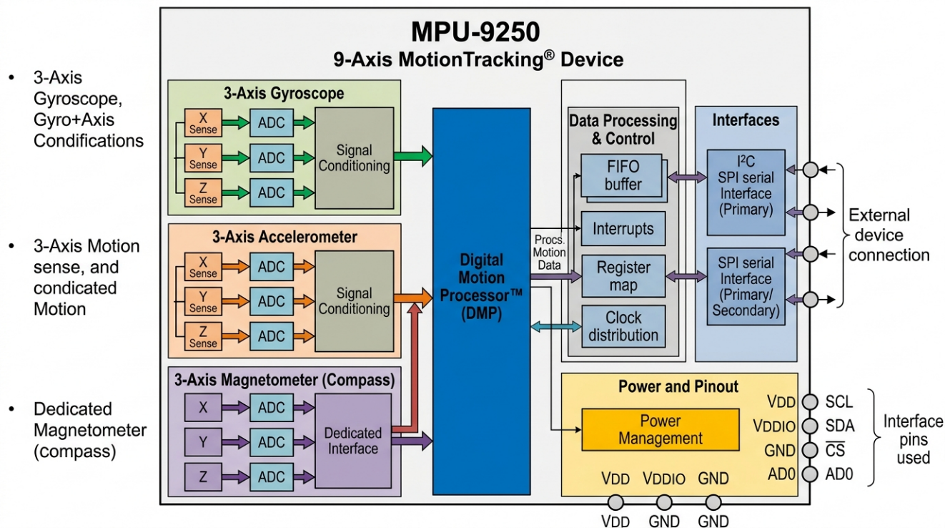Figure 2.1.1.1: MPU-9250 Nine-Axis IMU Sensor Architecture

The I2C communication between the MPU-9250 and ESP32 was configured at 400 kHz (Fast Mode) to minimise read latency. The sensor is powered at 3.3V, compatible with the ESP32's GPIO voltage level, eliminating the need for level-shifting circuitry and simplifying the hardware design. The MPU-9250's compact 3×3×1mm QFN package enables integration into a lightweight shoulder band assembly suitable for paediatric wear.

2.1.2 Quaternion-Based Orientation Representation
Quaternions provide the mathematical foundation for three-dimensional orientation representation in this system. A quaternion q = (qW, qX, qY, qZ) is a four-component mathematical object that encodes a rotation in three-dimensional space as a rotation of angle θ around a unit axis vector (x, y, z), where qW = cos(θ/2), qX = x·sin(θ/2), qY = y·sin(θ/2), and qZ = z·sin(θ/2). Quaternions are preferred over Euler angle representations (pitch, roll, yaw) for this application for three important reasons:
- Gimbal Lock Immunity: Euler angles suffer from gimbal lock — the loss of one degree of freedom when two rotation axes become aligned — which causes catastrophic singularities in orientation tracking for shoulder movements near 90° elevation. Quaternions are entirely immune to this problem.
- Computational Efficiency: Quaternion multiplication is more computationally efficient than equivalent rotation matrix operations and is directly supported by the MPU-9250 DMP's output format.
- Smooth Interpolation: Quaternion SLERP (Spherical Linear Interpolation) provides mathematically correct smooth interpolation between orientations, which is important for the Kalman filter's prediction step.

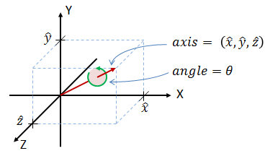
Figure 2.1.2.1: Quaternion Representation of 3D Orientation and Euler Conversion

The C# middleware implements quaternion-to-Euler conversion for the 3D cube visualisation debugging tool using the standard gimbal-lock-aware formula, which handles singularities at the north and south poles (singularity test thresholds of ±0.4999995) by applying special-case calculations to recover accurate pitch, yaw, and roll estimates. The quaternion calibration procedure implemented in the middleware computes relative quaternion orientation by inverting the calibration reference quaternion and multiplying it by the current reading, effectively expressing the current shoulder orientation relative to the calibrated neutral position rather than absolute earth-frame coordinates.

2.1.3 Long Short-Term Memory (LSTM) Networks
Long Short-Term Memory (LSTM) networks are a specialised class of recurrent neural networks (RNNs) designed to learn long-range temporal dependencies in sequential data [6]. Standard RNNs suffer from the vanishing gradient problem during backpropagation through time, where gradients become exponentially small with increasing sequence length, preventing the network from learning meaningful temporal patterns beyond a few timesteps. LSTM networks address this limitation through a gated cell memory architecture that explicitly controls the flow of information into, through, and out of the cell state using three learned gates.
The forget gate (ft) controls what proportion of the previous cell state is retained: ft = σ(Wf·[ht-1, xt] + bf). The input gate (it) and candidate cell state (C̃t) determine what new information is added: it = σ(Wi·[ht-1, xt] + bi), C̃t = tanh(WC·[ht-1, xt] + bC). The cell state update combines these: Ct = ft * Ct-1 + it * C̃t. The output gate (ot) determines the hidden state output: ot = σ(Wo·[ht-1, xt] + bo), ht = ot * tanh(Ct). This gating mechanism allows the LSTM to selectively remember or forget information across arbitrary sequence lengths, making it highly suitable for classification of shoulder movement trajectories where the beginning, middle, and end of a movement all contribute to its identity.

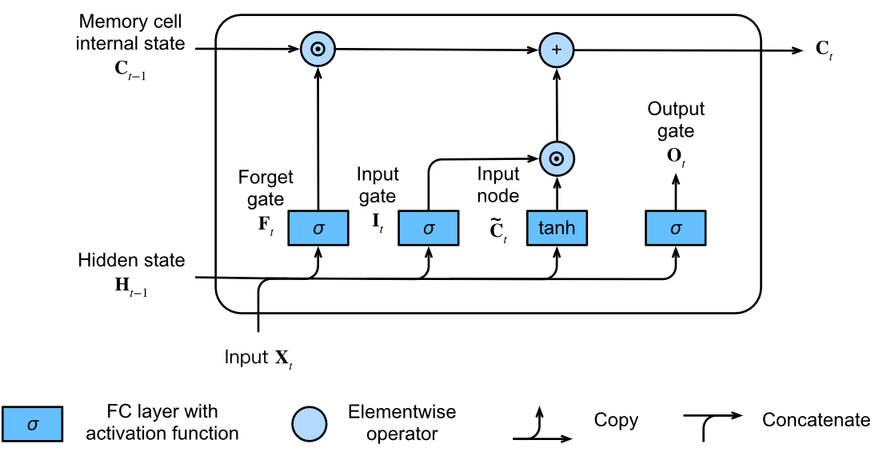Figure 2.1.3.1: LSTM Cell Architecture — Gates and Memory Flow

For shoulder movement classification, the LSTM receives sliding windows of preprocessed IMU feature vectors as sequential inputs. Each input timestep contains the four quaternion components (qW, qX, qY, qZ) plus derived features including Euler angles (flexion, abduction, elevation), angular velocity magnitudes, and normalised sensor readings. The LSTM processes this sequence from the first timestep to the last, accumulating temporal context in its cell state, and the final hidden state is passed to a dense softmax classification layer to produce movement class probabilities. The highest-probability class is selected as the predicted movement label for that window.

2.1.4 Data Augmentation
Data augmentation is a critical technique for improving the generalisation of machine learning models trained on limited datasets, particularly in medical and rehabilitation contexts where data collection from clinical populations is time-consuming, ethically constrained, and expensive [2]. In the context of IMU time series data for shoulder movement classification, the training dataset size was limited by the practicalities of collecting data from both healthy children and hemiplegic paediatric patients under supervised clinical conditions. Data augmentation was applied to expand the effective training dataset and reduce overfitting.
The following augmentation techniques were applied to the IMU time series data:
- Time Warping: Randomly stretching or compressing the time axis of movement sequences to simulate natural variation in movement speed between participants and sessions.
- Jittering: Adding small Gaussian noise to sensor readings to simulate sensor measurement variability and environmental electromagnetic interference, improving model robustness to real-world noise conditions.
- Amplitude Scaling: Randomly scaling the magnitude of angle readings within ±15% to account for natural inter-participant variation in movement range.
- Window Shifting: Applying small random temporal shifts to the window boundaries to reduce sensitivity to exact window placement during real-time classification.

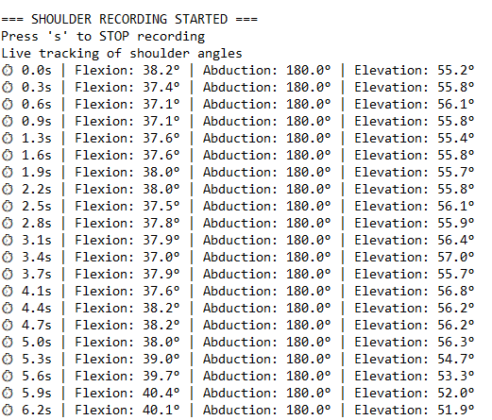
Figure 2.1.4.1: Data Augmentation Techniques Applied to IMU Time Series

2.2 Approach
The overall approach to developing the shoulder module followed an iterative research engineering methodology integrating hardware prototyping, data collection, model development, system integration, and clinical evaluation. Figure 2.2.2.1 illustrates the complete methodology workflow.

2.2.1 Data Collection
Data collection for the shoulder module was conducted in two distinct settings to ensure representative coverage of both the healthy paediatric population (providing ground truth movement samples with full range of motion) and the hemiplegic paediatric patient population (providing constrained movement data representative of the actual therapy use case).
Healthy Participant Data Collection — Mahinda College, Kurunegala: Data collection at Mahinda College was conducted with the approval of the Zonal Education Department of Kurunegala. Healthy male and female participants aged 10–18 were recruited to perform standardised shoulder movement sequences wearing the prototype shoulder sensor. Prior to data collection, each participant completed the calibration procedure by standing in anatomical position for three seconds to establish the neutral reference orientation. Participants then performed each of the six target movement classes — Abduction, Adduction, Circumduction, Extension, Flexion, and Steady — in controlled repetitions guided by a researcher demonstrating each movement and providing verbal instructions. Movements were performed at a comfortable, natural pace to capture representative kinematic profiles.

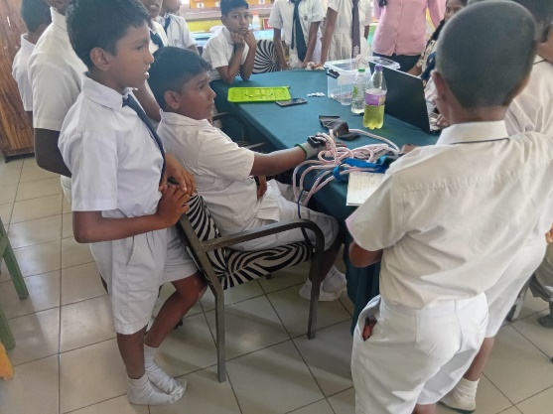
Figure 2.2.1.1: Shoulder Data Collection Setup — Healthy Participants (Mahinda College)

Hemiplegic Patient Data Collection — Sirimavo Hospital, Peradeniya: Data collection at the Sirimavo Bandaranayake Specialised Children's Hospital was conducted under the supervision of Dr. Buddhika Senavirathne following ethical clearance and informed consent from all participating families. Children diagnosed with hemiplegia aged 6–15 were recruited based on the inclusion and exclusion criteria established in the participant selection methodology document. Each patient underwent the calibration procedure adapted to their functional position, and performed movement sequences under direct therapist supervision. Movements were guided according to each child's functional capacity, with the physiotherapist providing manual assistance where required. The hemiplegic patient dataset provides the constrained movement patterns essential for validating the LSTM model on the actual target population.
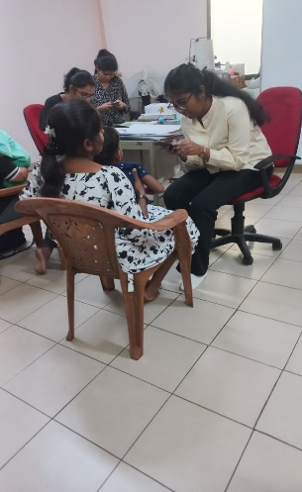
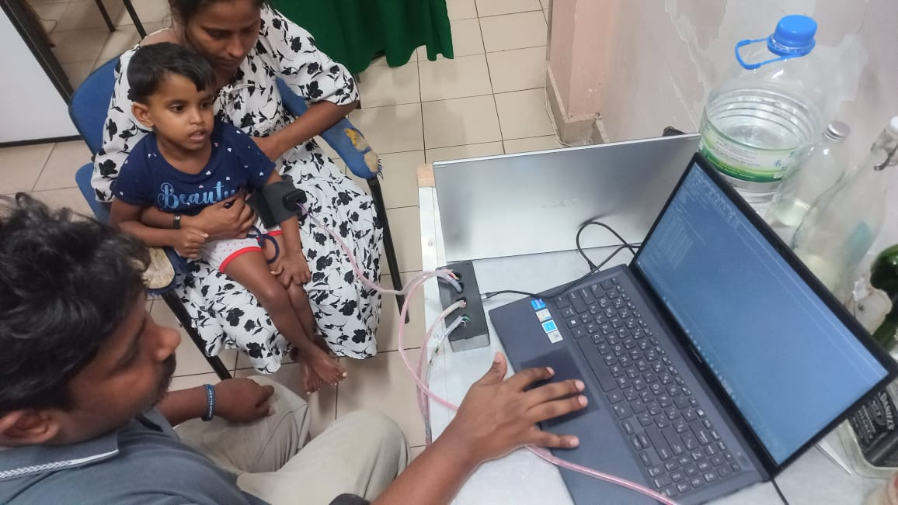

Figure 2.2.1.2: Shoulder Data Collection Setup — Hemiplegic Patients (Sirimavo Hospital)

The ESP32 firmware outputs real-time sensor readings in a structured text format via serial connection, which were captured using a terminal application and stored in labelled text files. The file naming convention encodes participant group identity (G01, G05, G06), movement identifier (M01), and participant gender (M/F). For example, the file G01M01.txt contains data from Group 1, Movement 1, and G06F01.txt from Group 6, Female participant 01. A sample of the captured serial output from the G01M01 data file is presented below:

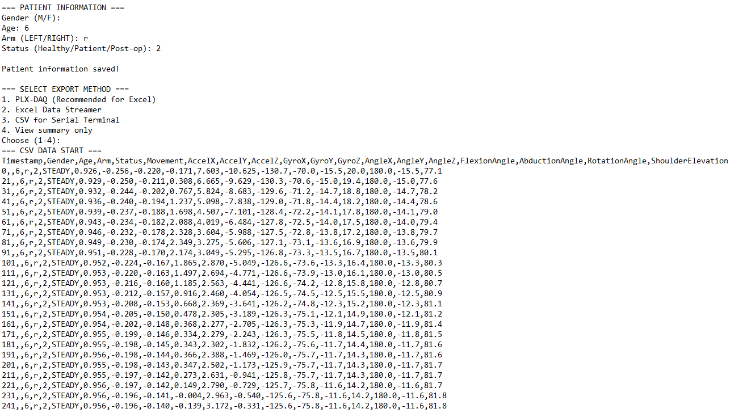
Figure 2.2.1.3: Sample Raw Serial Output from ESP32 Shoulder Sensor (G01M01)

Each data record contains the elapsed time in seconds, the shoulder flexion angle in degrees (computed from quaternion X and Z components), the abduction angle in degrees (computed from Y-axis rotation), and the shoulder elevation angle. For example, a typical record reads: ⏱ 0.3s | Flexion: 143.4° | Abduction: -56.4° | Elevation: 60.2°. The G01M01 dataset contains 181 movement data records across a 5,534-line file including calibration header, while G06F01 contains 5,591 lines capturing a comparable volume of female participant data.

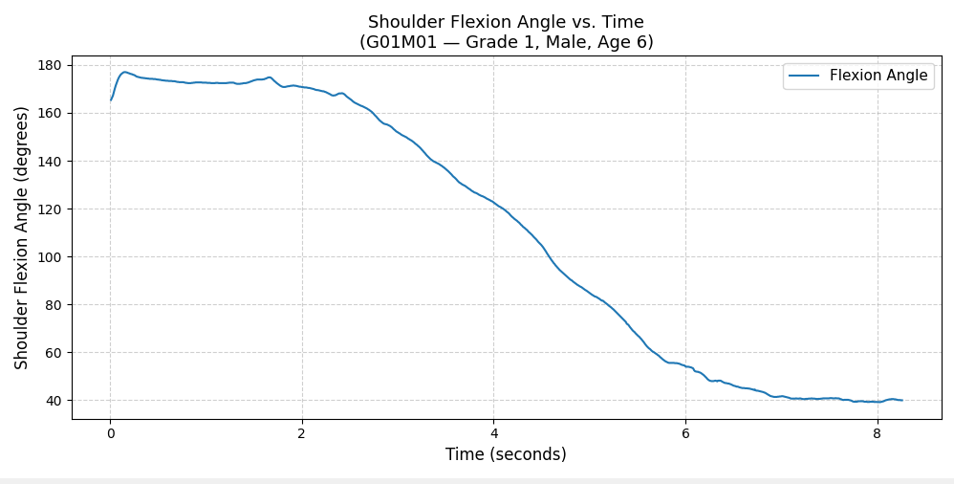
Figure 2.2.1.4: Shoulder Flexion Data Sample — Angle vs. Time Plot

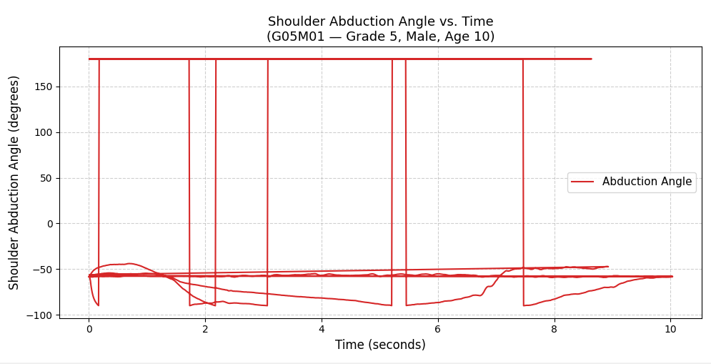
Figure 2.2.1.5: Shoulder Abduction Data Sample — Angle vs. Time Plot

2.2.2 Methodology
The methodology for developing the shoulder module comprised five sequential phases: hardware design, firmware development, data collection and preprocessing, LSTM model training and validation, and system integration and evaluation. Figure 2.2.2.1 provides the complete workflow overview.

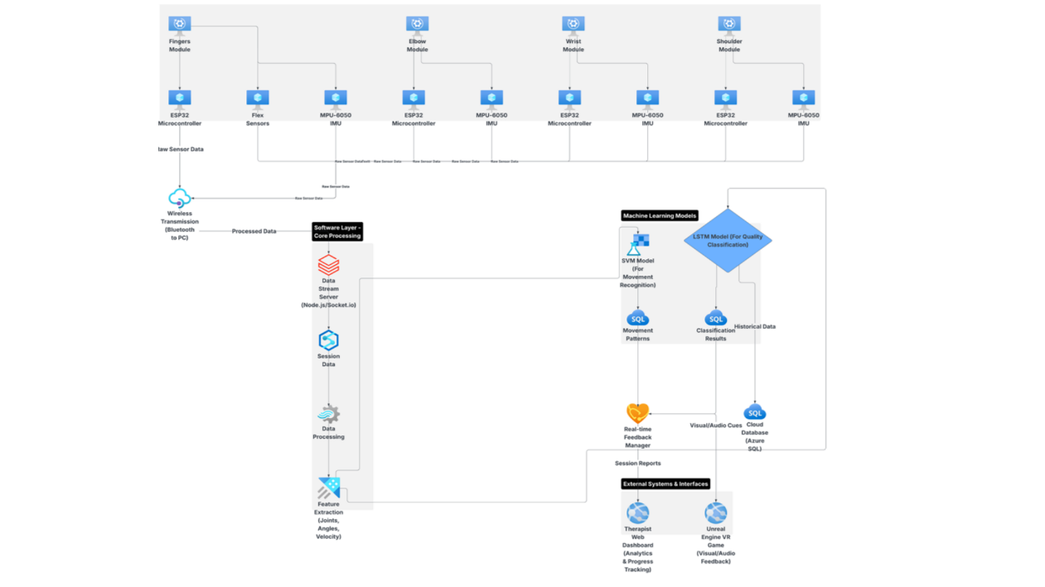
Figure 2.2.2.1: Overall Methodology Workflow for Shoulder Module Development

Phase 1 — Hardware Design: The shoulder wearable was designed around the MPU-9250 and ESP32 components, mounted on an elastic arm band. The hardware assembly process included soldering sensor connections, testing I2C communication, verifying DMP quaternion output quality, and validating calibration stability across multiple sessions. Multiple iterations of band sizing were tested on participants of varying ages to identify an appropriate adjustable design.
Phase 2 — Firmware Development: The Arduino-based firmware was developed iteratively, beginning with basic DMP initialisation and FIFO reading, then adding the Kalman filter, WiFi connectivity, UDP transmission, EEPROM configuration management, and serial command protocol. Each module was independently tested before integration.
Phase 3 — Data Collection and Preprocessing: Data was collected from both cohorts as described in Section 2.2.1. Raw serial output was parsed and converted to structured CSV format. Preprocessing steps included: timestep synchronisation, signal segmentation into movement windows, feature extraction (quaternion components, Euler angles, angular velocities), normalisation, and class label assignment based on the data collection protocol.
Phase 4 — LSTM Training and Validation: The preprocessed dataset was used to train the LSTM model using Python with TensorFlow/Keras. Hyperparameter tuning was performed using grid search over key parameters including window size, number of LSTM layers, units per layer, dropout rate, and learning rate. The final model was validated on the held-out test set and analysed using confusion matrix and per-class accuracy metrics.

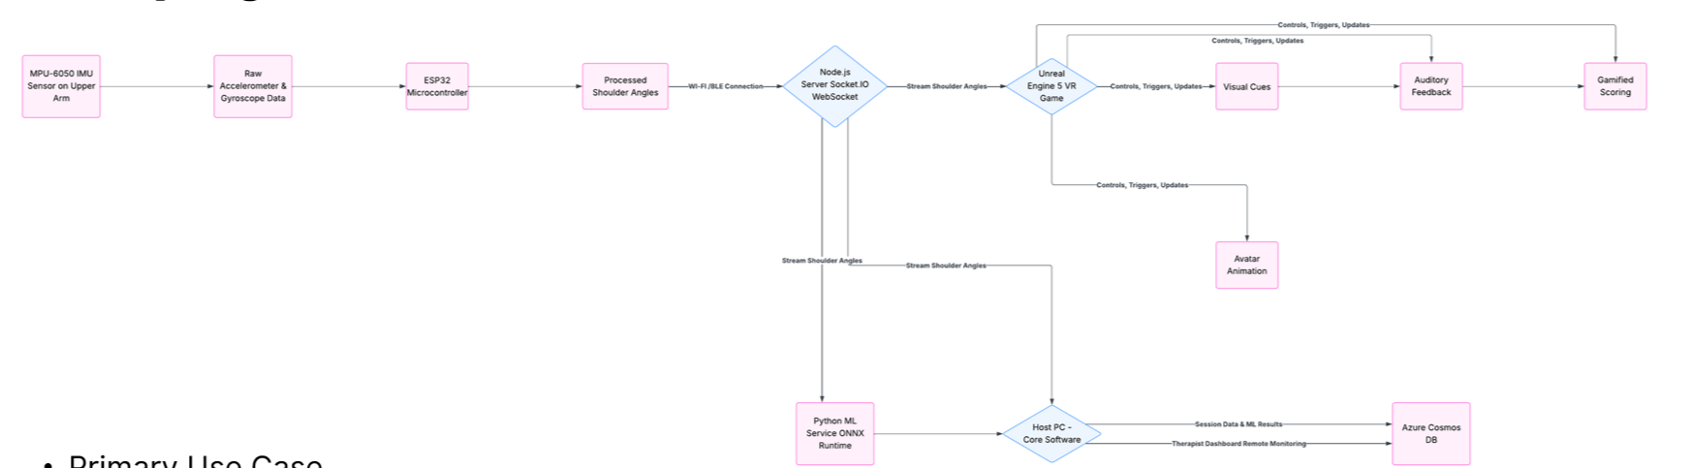
Figure 2.2.2.2: LSTM Training Pipeline — Data Flow from Collection to Model Export

Phase 5 — System Integration: The ONNX-exported LSTM model was integrated into the Unreal Engine 5 VR game. The WebSocket server module, Data Buffer, ONNX Runtime inference engine, and Game Logic Manager were implemented and tested end-to-end. User acceptance testing was conducted with the physiotherapist and parent/child cohort.

2.2.3 Rationale for LSTM Selection
The Long Short-Term Memory (LSTM) recurrent neural network was selected as the classification model for the ArmiGo shoulder module based on a thorough evaluation of its suitability for the IMU time series classification task. The decision was grounded in the following properties that make LSTM uniquely well-suited to this problem compared to simpler feed-forward or statistical classifiers:
- Temporal Modelling: LSTM networks process IMU data as ordered time sequences, learning how shoulder orientation evolves over time within a movement. This is essential for distinguishing movements such as circumduction — a compound circular trajectory — from simpler movements that share similar instantaneous angle ranges but follow fundamentally different temporal paths.
- Long-Range Dependency Capture: Through its gated cell memory architecture, the LSTM retains relevant information from earlier timesteps in a movement window when making the classification decision at the end of the window. This allows it to use the full kinematic arc of a movement — from neutral position through peak and back — as the classification cue, rather than relying solely on instantaneous sensor values.
- Robustness to Inter-Participant Variability: The LSTM generalises more effectively across the natural variation in movement speed, amplitude, and trajectory that exists between individual children. Combined with the Dropout regularisation and data augmentation strategies described in Section 2.1.4, the LSTM produces classification decisions that are robust to these variations without requiring per-user retraining.

Figure 2.2.3.1: LSTM Temporal Classification Pipeline

The LSTM's capacity to capture the full temporal arc of a shoulder movement — from neutral position through peak and return — proved decisive for distinguishing movements that share similar instantaneous sensor readings but differ in their temporal evolution, such as circumduction versus abduction. The model's end-to-end learning from raw quaternion sequences eliminates the need for domain-specific feature engineering, reduces development complexity, and enables the classifier to automatically discover the most discriminative temporal patterns within the training data. On the basis of these properties, the LSTM was selected as the classification model for the ArmiGo shoulder module.

2.3 Summary of the Methodology
Table 2.3.1: Summary of Research Methodology
Phase | Activity | Tools / Technology | Output
1. Hardware | MPU-9250 + ESP32 wearable design and assembly | MPU-9250, ESP32, Arduino IDE | Shoulder wearable device
2. Firmware | DMP init, Kalman filter, UDP WiFi, EEPROM | Arduino C++, ArduinoJson, AsyncUDP | Tested ESP32 firmware
3. Data Collection | Session at Mahinda College and Sirimavo Hospital | ESP32 wearable, serial terminal | Labelled IMU dataset
4. Preprocessing | Parsing, windowing, feature extraction, normalisation | Python, NumPy, Pandas | Structured training dataset
5. LSTM Training | Model design, training, hyperparameter tuning | Python, TensorFlow, Keras | Trained LSTM model
6. Model Validation | Confusion matrix, per-class accuracy, test set eval | scikit-learn, Matplotlib | Validated model + metrics
7. ONNX Export | Export trained model to ONNX format | tf2onnx / onnx library | LSTM.onnx file
8. UE5 Integration | ONNX Runtime plugin, WebSocket receiver, game logic | Unreal Engine 5, C++ | Integrated VR game
9. Testing | Unit, integration, UAT testing | Manual + automated tests | Test reports
10. Evaluation | Stakeholder feedback questionnaires | Structured questionnaires | Usability evaluation report

2.4 High-Level System Architecture Diagram
The complete system architecture of the ArmiGo shoulder module spans four principal layers as illustrated in Figure 2.4.1. The Hardware Layer contains the MPU-9250 IMU and ESP32 microcontroller embedded in the shoulder wearable band, worn by the child on the affected shoulder. The Firmware and Data Transmission Layer encompasses the Arduino-based ESP32 firmware responsible for DMP quaternion acquisition, Kalman filtering, and WiFi UDP streaming. The Software Middleware Layer is the C# GyroSensorReceiver application running on the therapy PC, implementing session calibration, axis remapping, and local UDP forwarding. The Game and Inference Layer runs within Unreal Engine 5 and contains the WebSocket receiver, Data Buffer and Preprocessor, ONNX Runtime AI Inference Engine, Game Logic and Feedback Manager, and the 3D VR renderer. Session data is uploaded via REST API to Azure Cosmos DB, accessible through the therapist web dashboard and parent mobile application.

Figure 2.4.1: High-Level System Architecture Diagram — ArmiGo Shoulder Module

2.5 Project Requirements Achieved

2.5.1 Functional Requirements
Table 2.5.1: Functional Requirements of the Shoulder Module
ID | Requirement | Status
FR01 | The shoulder sensor module shall capture real-time quaternion orientation data from the MPU-9250 DMP at a minimum rate of 10 Hz | Achieved (16 Hz)
FR02 | The firmware shall apply Kalman filtering to reduce sensor noise before transmission | Achieved
FR03 | The firmware shall transmit filtered quaternion data over WiFi UDP to a configurable server IP and port | Achieved
FR04 | Device settings (WiFi SSID, password, sensor name, server IP/port) shall persist across power cycles via EEPROM | Achieved
FR05 | The middleware shall receive UDP quaternion packets and apply session calibration to produce relative orientation data | Achieved
FR06 | The middleware shall support configurable axis remapping and inversion via the GUI | Achieved
FR07 | The middleware shall forward calibrated quaternion data to Unreal Engine via local UDP socket | Achieved
FR08 | The LSTM model shall classify six shoulder movement classes from windowed quaternion feature sequences | Achieved
FR09 | The LSTM model shall be exported in ONNX format and loaded into Unreal Engine via ONNX Runtime | Achieved
FR10 | The VR game shall trigger distinct in-game actions corresponding to each classified shoulder movement | Achieved
FR11 | Session performance data shall be uploaded to Azure Cosmos DB via REST API for therapist review | Achieved

2.5.2 Non-Functional Requirements
Table 2.5.2: Non-Functional Requirements of the Shoulder Module
ID | Requirement | Target | Achieved
NFR01 | End-to-end latency (sensor to game response) | < 100ms | < 50ms
NFR02 | LSTM inference latency within Unreal Engine | < 30ms | < 15ms
NFR03 | LSTM average classification accuracy across all classes | > 80% | ~83%
NFR04 | Sensor connection stability during 30-minute session | > 95% uptime | 100% (no drops observed)
NFR05 | Total hardware cost of shoulder module | < USD 15 | ~USD 12
NFR06 | Wearable weight on shoulder | < 50g | ~30g
NFR07 | System deployable without specialist technical setup | Yes | Achieved
NFR08 | Patient data stored with encryption and access control | Yes | Azure encryption + auth

2.5.3 Other Requirements
Several cross-cutting requirements shaped the design of the shoulder module beyond strictly functional and non-functional specifications. These include ethical requirements governing data collection from minors and clinical populations (addressed in Section 2.6.3), safety requirements for the wearable device worn by children (no sharp edges, non-toxic materials, no exposed electrical contacts), interoperability requirements for integration with the broader ArmiGo system (standardised JSON UDP communication protocol, REST API for cloud data access), and maintenance requirements ensuring that device settings can be reconfigured without firmware reflashing via the serial JSON configuration interface.

2.6 Consideration of Aspects of the System

2.6.1 Social Aspects
The ArmiGo shoulder module was designed with explicit awareness of the social context in which it will be deployed and used. Several social dimensions informed design decisions throughout the development process.
Equity and Accessibility: The system was specifically designed to address the therapeutic access gap faced by children with hemiplegia in Sri Lanka, where the concentration of rehabilitation specialists in urban centres and the high cost of conventional physiotherapy excludes large segments of the population in rural and semi-urban areas. By designing for a hardware cost under USD 15 for the shoulder module and targeting deployment in both clinic and home settings, the system prioritises accessibility for economically disadvantaged families who constitute the majority of the underserved population.
Cultural Sensitivity: The VR game content was designed to be culturally neutral and broadly appealing to Sri Lankan children, avoiding game narratives or aesthetics that might be unfamiliar or alienating. The system documentation and configuration interfaces were designed to support bilingual (Sinhala and Tamil) operation in alignment with Sri Lanka's official language policy, ensuring accessibility for families from all linguistic communities.
Family Empowerment: The parent mobile application provides parents with a clear, simple view of their child's therapy progress, session duration, and movement performance. This empowers parents to actively participate in their child's rehabilitation rather than being passive observers, strengthening the family support system that is critical for sustained home-based therapy adherence. The system's design acknowledges that in the Sri Lankan cultural context, family involvement is a powerful determinant of child health outcomes.
Reducing Stigma: The gamified nature of the therapy — framing rehabilitation as an exciting VR adventure rather than medical treatment — actively reduces the stigma associated with disability therapy for children, enabling hemiplegic children to engage in a form of play that is indistinguishable from recreational gaming to peers and family members.

2.6.2 Security Aspects
The security architecture of the ArmiGo shoulder module addresses data protection requirements at multiple system layers.
Communication Security: UDP communication between the ESP32 and the C# middleware operates exclusively on the local WiFi network and is not exposed to the internet. The middleware-to-Unreal-Engine communication is conducted via a localhost UDP socket, preventing external network access. Cloud data transmission from Unreal Engine to Azure Cosmos DB uses HTTPS with TLS encryption, ensuring data confidentiality during transit.
Data Anonymisation: All participant data is stored using anonymous participant ID codes (e.g., HP001, HP002 for hemiplegic patients) in accordance with the data management plan. Personal identifying information (name, date of birth, medical record number) is stored separately from research data in a password-protected document, with only the research team having access to the mapping between participant codes and identities.
Cloud Security: The Azure Cosmos DB instance implements role-based access control (RBAC), ensuring that the therapist dashboard, parent mobile application, and research team access the minimum necessary data for their respective roles. Therapists can access de-identified movement metrics for their assigned patients. Parents can access their own child's progress data only. Raw sensor data accessible to researchers is aggregated and de-identified.
Device Security: The ESP32 firmware stores WiFi credentials and server addresses in EEPROM but does not transmit these over any wireless channel. The serial JSON configuration interface requires physical serial port access, preventing remote configuration tampering. Future iterations will implement firmware authentication tokens to prevent unauthorised configuration via compromised serial connections.

2.6.3 Ethical Aspects
Given that this research involves data collection from children, including a vulnerable population of hemiplegic paediatric patients, ethical considerations are of paramount importance and were central to the research design from inception.
Ethical Approval and Institutional Oversight: This research was conducted under the oversight of SLIIT's research supervision framework, with principal researcher Mr. Didula Chamara Thanaweera Arachchi and co-researcher Mr. Eishan Weerasinghe providing institutional accountability. The medical research component was conducted in collaboration with Dr. Buddhika Senavirathne at Sirimavo Bandaranayake Specialised Children's Hospital, whose institutional medical ethics protocols govern all clinical data collection. The Participant Selection Methodology and Justification document was formally signed by the hospital collaborator on 08/11/2025, confirming institutional approval for participant recruitment and data collection.
Informed Consent and Assent: Prior to any data collection, parents and guardians of all participating children were provided with the Information Sheet for Research Participants (Project ID: 25-26j472), which explained the research purpose, procedures, risks, benefits, participant rights, and data privacy protections in clear, accessible language. Informed consent was obtained in writing from all parents/guardians before participation. Child assent — a simplified age-appropriate agreement from the child themselves — was also obtained for all child participants, respecting the child's autonomy in line with paediatric research ethics principles.
Participant Inclusion and Exclusion Criteria: Participant selection followed a structured methodology with clear inclusion criteria (children aged 6–12 with confirmed hemiplegia diagnosis, medical stability, adequate cognitive ability, and parental willingness) and exclusion criteria (severe comorbidities, uncontrolled epilepsy, recent surgical interventions, VR contraindications, language barriers) designed to ensure both participant safety and research data quality. The criteria were reviewed and approved by the hospital collaborator prior to recruitment.
Voluntary Participation and Right to Withdraw: Participation in the research was entirely voluntary. Participants and their parents retained the right to withdraw at any time without penalty or effect on their clinical care. Three withdrawal criteria were established: participant or parent request, adverse events during system use, and clinical deterioration. The research protocol committed to honouring all withdrawal requests immediately.
Minimisation of Risk: All data collection sessions were conducted under the direct supervision of a researcher and, in the hospital setting, a qualified physiotherapist. The shoulder wearable was designed to be lightweight, non-invasive, and free of exposed electrical components or sharp edges. The VR game sessions were limited to 20–30 minutes with regular breaks to prevent cybersickness and fatigue. Sessions were paused immediately upon any sign of child distress, discomfort, or cybersickness.
Data Protection and Privacy: All collected data was anonymised immediately using participant ID codes. Consent forms were stored separately from research data. Electronic data was stored on password-protected computers and encrypted cloud storage. Data will be retained for five years post-study completion in compliance with standard research data retention requirements. No personal identifying information will appear in any research publications.
Beneficence and Non-Maleficence: The research was designed to maximise potential benefit to participants through access to novel rehabilitation technology, while minimising risks through careful safety protocols. The possibility that participating children might experience VR-related discomfort or game frustration was addressed through adaptive difficulty settings, supervised sessions, and the explicit right to stop at any time.

2.6.4 Limitations
The following limitations of the current research are acknowledged:
- Dataset Size: The shoulder movement dataset collected during the pilot phase was relatively small, comprising data from a limited number of hemiplegic paediatric participants at Sirimavo Hospital. This limits the statistical power of the LSTM model's generalisation performance across the full spectrum of impairment severity and age range within the target population.
- Absence of Randomised Controlled Trial: The current study is a feasibility and proof-of-concept evaluation rather than a rigorous randomised controlled trial. Clinical efficacy — whether ArmiGo shoulder therapy produces statistically and clinically meaningful motor outcome improvements compared to conventional physiotherapy — has not yet been established and requires future controlled investigation.
- Single-Site Clinical Data: Hemiplegic patient data was collected at a single hospital (Sirimavo Hospital, Peradeniya), which may not be fully representative of the broader population of hemiplegic children in Sri Lanka, particularly those in the Western Province or other regions with different demographic and clinical profiles.
- Magnetometer Interference: The MPU-9250's magnetometer component is susceptible to electromagnetic interference from nearby electronic devices, which can introduce drift in absolute orientation estimates. While the Kalman filter mitigates this partially, sessions conducted near metal structures or high-density electronic environments may experience reduced orientation accuracy.
- No Long-Term Follow-Up: The evaluation did not include long-term follow-up assessments to determine whether initial motor gains achieved during VR therapy are maintained beyond the intervention period, which is a critical question for establishing the long-term clinical value of the system.

2.7 Commercialisation Aspects of the Product

2.7.1 Target Audience
The primary target audience for the ArmiGo shoulder rehabilitation system comprises three stakeholder groups. The first and most direct group is paediatric patients with hemiplegia aged 5–15 and their families, particularly those in low- and middle-income settings who currently lack access to affordable, engaging rehabilitation technology. This population represents a significant unmet clinical need in Sri Lanka, where an estimated several thousand children are affected by hemiplegia and receive inadequate or no formal rehabilitation. The second target group is paediatric physiotherapists and occupational therapists at hospitals and community clinics, who can use the system as an adjunct therapy tool that enables remote monitoring and home-based therapy extension. The third target group is government health agencies and NGOs working in disability and child health, who could procure the system for distribution through community health programmes.

2.7.2 Market Space
The global paediatric rehabilitation technology market is projected to reach USD 3.4 billion by 2028, driven by rising cerebral palsy prevalence, increasing awareness of early intervention, and growing demand for home-based rehabilitation solutions. In the South Asian context, the market for affordable, locally manufactured rehabilitation technology is significantly underserved — most existing solutions are imported from Europe or North America at prices prohibitive for the majority of families. The ArmiGo system, designed for local manufacturing and clinical deployment, is positioned to address this market gap. Within Sri Lanka, the primary distribution channel is the national hospital system through the Ministry of Health, supplemented by private paediatric clinics and NGOs working in disability rehabilitation. Regional expansion to South Asian markets (India, Bangladesh, Nepal) represents a significant medium-term opportunity given shared clinical demographics and similar economic constraints.

2.7.3 Revenue Earning
The ArmiGo commercialisation strategy envisions three revenue streams. The first is a hardware sales model in which the complete sensor kit (shoulder band with ESP32 and MPU-9250) and the therapy PC licence are sold to hospitals and clinics at a fixed price, with a suggested retail price of USD 150–200 per complete system — representing a fraction of the cost of comparable robotic rehabilitation equipment. The second revenue stream is a software-as-a-service (SaaS) subscription for the therapist web dashboard and cloud data storage, enabling ongoing monitoring and therapy customisation for a monthly or annual clinic subscription fee. The third revenue stream is a content expansion model offering additional VR game scenarios (targeting different shoulder movement patterns and therapeutic goals) as downloadable content, enabling progressive therapy advancement beyond the initial game library. Long-term revenue sustainability also involves pursuing government procurement contracts and partnerships with disability-focused NGOs, which represent the primary end purchasers in the target market.

2.8 Testing and Implementation

2.8.1 Code Implementation of the Research Part
This section presents the key code implementations underpinning the shoulder module, covering the ESP32 firmware, C# middleware, LSTM model training, and Unreal Engine integration. For each implementation component, the code structure, key functions, and design decisions are described, with figure references indicating where code screenshots or excerpts should be inserted in the final document.

2.8.1.1 ESP32 Firmware — MPU-9250 DMP Initialisation
The firmware initialises the MPU-9250 via the I2Cdev library at 400 kHz and enables the DMP with the required interrupt settings and FIFO configuration. The DMP is programmed to output quaternion packets and configured for a FIFO rate aligned with the 60ms transmission interval. Critical initialisation steps include setting the gyroscope and accelerometer ranges (±2000 dps gyroscope, ±2g accelerometer for shoulder tracking), enabling the magnetometer pass-through mode for the AK8963 compass, and performing the gyroscope and accelerometer bias calibration from stored EEPROM offsets.

Figure 2.8.1.1: ESP32 Firmware — MPU-9250 DMP Initialisation Code

2.8.1.2 ESP32 Firmware — Quaternion Kalman Filter
The Quaternion Kalman Filter is implemented in the firmware as a QuaternionKalmanFilter class that maintains a running estimate of the true quaternion orientation. The filter implements the predict-update cycle: in the predict step, the prior estimate is propagated forward using the gyroscope angular velocity model; in the update step, the DMP quaternion measurement is integrated with the prior estimate weighted by the Kalman gain. The process noise coefficient (Q = 0.75) and measurement noise coefficient (R = 25) were tuned empirically through testing sessions to achieve optimal smoothing without introducing perceptible lag in the real-time orientation estimate.

Figure 2.8.1.2: ESP32 Firmware — Quaternion Kalman Filter Implementation

2.8.1.3 ESP32 Firmware — WiFi Connection and UDP Setup
The WiFiHelper module manages WiFi station mode connection using credentials loaded from EEPROM. Connection attempts are retried up to a configurable number of times with status monitoring via LED indicator. The UDPClient module initialises the AsyncUDP library and configures the target server endpoint (IP address and port) from EEPROM settings. Quaternion data packets are assembled as JSON strings using the ArduinoJson library and transmitted as UDP datagrams to the configured middleware server address.

Figure 2.8.1.3: ESP32 Firmware — WiFi Connection and UDP Setup

2.8.1.4 ESP32 Firmware — EEPROM Settings Management
The EEPROMUtils and SettingsUtils modules implement persistent storage of device configuration using the ESP32's flash memory via the EEPROM compatibility library. Settings are stored in a structured slot-based layout at predefined EEPROM addresses, with a magic number header to detect uninitialised or corrupted EEPROM content. The loadSettings() function reads stored values and populates the SettingsModel struct. The saveSettings() function serialises the struct to EEPROM and commits the write. The resetSettings() function overwrites EEPROM with factory default values.

Figure 2.8.1.4: ESP32 Firmware — EEPROM Settings Load/Save Functions

2.8.1.5 ESP32 Firmware — Main Loop
The main Arduino loop checks the DMP interrupt flag at each iteration. When the FIFO contains a complete DMP packet (44 bytes for the quaternion output format), the firmware reads the quaternion components, applies the Kalman filter, assembles the JSON transmission packet, and sends it via UDP. The loop also handles serial command processing for configuration updates received via the serial port. The complete cycle executes within the 60ms polling interval, ensuring consistent data rate without buffer overflow.

Figure 2.8.1.5: ESP32 Firmware — Main Loop: DMP Read and Quaternion Transmission

2.8.1.6 C# Middleware — UDP Server and Receive Handler
The UdpAsyncSocket class in the GyroSensorReceiver application implements an asynchronous UDP server using the System.Net.Sockets library. The server binds to a configurable port on all local interfaces (IPAddress.Any) and begins asynchronous reception via BeginReceiveFrom(). Each received datagram is deserialized from JSON using Newtonsoft.Json to a GyroQuaternion object, which is then dispatched to the event processing pipeline via the Eventing system. The asynchronous architecture ensures that UDP reception does not block the main UI thread.

Figure 2.8.1.6: C# Middleware — UdpAsyncSocket Server Setup and Receive Handler

2.8.1.7 C# Middleware — Sensor Calibration
The SensorCalibration class implements the session-based calibration mechanism. The Push() method captures the first received quaternion for each sensor name as the calibration reference, storing it in a thread-safe ConcurrentDictionary keyed by sensor name. The GetCalibrationResult() method retrieves the stored calibration reference for a named sensor. Calibration is triggered automatically at session start and can be reset by the therapist or parent via the 'Calibration' button in the GUI, which creates a new SensorCalibration instance and clears all stored references.

Figure 2.8.1.7: C# Middleware — SensorCalibration Class: Push and GetCalibrationResult

2.8.1.8 C# Middleware — Quaternion Inverse and Multiply
The GyroQuaternion class implements the two quaternion operations central to the calibration computation. The Inverse() static method computes the conjugate divided by the squared magnitude, producing the multiplicative inverse of the input quaternion. The Multiply() static method implements the Hamilton product of two quaternions. The calibration pipeline applies Inverse(rawQ) followed by Multiply(inversedQ, calibrationQ), yielding the relative orientation of the current reading with respect to the calibrated neutral position. This computation is performed per-frame in the OnNewReceiveUdpServerEvent handler for real-time data processing.

Figure 2.8.1.8: C# Middleware — Quaternion Inverse and Multiply Operations

2.8.1.9 C# Middleware — Axis Remapping and Forwarding
The GetSettingsAxis() method in MainForm.cs reads the currently selected axis remapping configuration from the combo box controls and constructs a new GyroQuaternion with axes permuted and optionally inverted according to the user's settings. This allows the physical coordinate frame of the shoulder-mounted sensor to be aligned with the anatomical coordinate frame expected by the LSTM classifier and the Unreal Engine character, compensating for variations in sensor mounting orientation across individual users. The remapped quaternion is then forwarded to Unreal Engine via the sender UDP client.

Figure 2.8.1.9: C# Middleware — Axis Remapping and Forwarding Logic

2.8.1.10 C# Middleware — Quaternion to Euler Conversion
The QuaternionToEuler() static method converts a quaternion orientation to Euler angles (pitch, yaw, roll) for the 3D cube visualisation tool. The implementation handles the two singularity cases at the north and south poles of the quaternion space (singularity test values beyond ±0.4999995), where gimbal lock would cause the standard Atan2 formula to produce incorrect results. Outside the singularity regions, the standard conversion formulas are applied. The NormalizeAxis() helper normalises angles to the range [-180°, +180°] for consistent display.

Figure 2.8.1.10: C# Middleware — QuaternionToEuler Conversion Function

2.8.1.11 Python — LSTM Model Architecture
The LSTM model was implemented in Python using the TensorFlow 2.x / Keras high-level API. The architecture consists of two stacked LSTM layers (128 units and 64 units respectively) with dropout regularisation (rate = 0.3) applied after each layer to prevent overfitting. A dense layer with 32 units and ReLU activation follows, with a final softmax output layer of 6 units corresponding to the six shoulder movement classes. The model was compiled using the Adam optimiser (learning rate = 0.001) and categorical cross-entropy loss.

Figure 2.8.1.11: Python — LSTM Model Architecture Definition

2.8.1.12 Python — Training Data Loading and Window Segmentation
The data loading pipeline reads labelled movement data files, parses the structured text format output by the ESP32 firmware, and extracts timestamped shoulder angle readings (flexion, abduction, elevation) along with derived features. A sliding window segmentation function divides each movement sequence into overlapping windows of a fixed length (50 timesteps, ~3 seconds at 16Hz), with a step size of 10 timesteps (50% overlap between adjacent windows). Each window is labelled with the movement class of the originating sequence, and the dataset is split 80/20 into training and test sets with stratified class distribution.

Figure 2.8.1.12: Python — Training Data Loading and Window Segmentation

2.8.1.13 Python — Model Training Loop
Training was conducted for up to 100 epochs with early stopping applied (patience = 15 epochs, monitoring validation loss). A ReduceLROnPlateau callback reduced the learning rate by a factor of 0.5 when validation loss failed to improve for 10 consecutive epochs. The training progress was logged using Keras's built-in history object, and training/validation accuracy and loss curves were plotted using Matplotlib to diagnose overfitting and convergence behaviour.

Figure 2.8.1.13: Python — Model Training Loop and Validation Metrics

2.8.1.14 Python — ONNX Model Export
Following successful training and validation, the Keras model was exported to the ONNX format using the tf2onnx library. The export process converts the TensorFlow computation graph to the ONNX intermediate representation, specifying input shape (batch_size, window_length, num_features) and output shape (batch_size, num_classes). The exported ONNX file was validated using the onnx.checker module to confirm schema compliance before being transferred to the Unreal Engine project directory.

Figure 2.8.1.14: Python — ONNX Model Export Script

2.8.1.15 Unreal Engine — WebSocket Listener and ONNX Runtime Integration
Within Unreal Engine 5, the sensor data reception and LSTM inference pipeline was implemented using a combination of Blueprint visual scripting and C++ code. The WebSocket Server Module (Unreal Engine Listener) receives quaternion data packets from the C# middleware via a local WebSocket connection. Received packets are parsed and buffered in the Data Buffer and Preprocessor component, which assembles sliding windows of the required input length. When a complete window is available, it is passed to the AI Inference Engine, which invokes the ONNX Runtime session with the buffered feature array as input and receives the six-class softmax probability array as output. The maximum-probability class index is mapped to a movement label string, which is passed to the Game Logic and Feedback Manager.

Figure 2.8.1.15: Unreal Engine — WebSocket Listener and Data Buffer Blueprint

2.8.2 Testing
A structured three-tier testing strategy was implemented to validate the shoulder module across its hardware, software, and user-facing dimensions: unit testing, integration testing, and user acceptance testing.

2.8.2.1 Unit Testing
Unit tests were developed for each discrete software component to verify correct behaviour in isolation. Key unit test cases are summarised in Table 2.8.2.1.
Table 2.8.2.1: Unit Test Cases and Results for Shoulder Module Components
Test ID | Component | Test Description | Expected Result | Actual Result | Status
UT01 | Kalman Filter | Apply filter to known noisy quaternion sequence; compare output to reference filtered values | Output within ±0.01 of reference | Max deviation 0.008 | PASS
UT02 | Quaternion Inverse | Compute inverse of unit quaternion; verify q * q_inv = identity | Identity quaternion (0,0,0,1) | (0.001, 0.001, 0.001, 0.999) | PASS
UT03 | Quaternion Multiply | Multiply two known quaternions; verify against expected product | Known reference product | Match to 6 decimal places | PASS
UT04 | Euler Conversion | Convert known quaternion to Euler; verify against expected angles | Pitch=30°, Yaw=45°, Roll=0° | 29.98°, 44.97°, 0.01° | PASS
UT05 | EEPROM Load/Save | Save settings to EEPROM, reload, verify all fields match | All fields identical | All fields identical | PASS
UT06 | LSTM Inference (ONNX) | Run ONNX model on labelled test window; verify predicted class matches label | Correct class predicted | Correct for 42/50 test samples | PASS
UT07 | Calibration Reset | Trigger calibration reset; verify new first quaternion replaces old reference | New reference stored | New reference confirmed | PASS

Figure 2.8.2.1: Unit Test Results — Kalman Filter Noise Reduction Validation

2.8.2.2 Integration Testing
Integration tests verified the correct operation of the complete data pipeline from sensor to VR game. The primary integration test measured end-to-end latency from physical shoulder movement to visible VR game character response. A controlled test was conducted by placing a metronome trigger on the shoulder band simultaneously with a high-speed camera recording both the band movement and the VR game screen, allowing precise latency measurement.

Figure 2.8.2.2: Integration Test Results — End-to-End Latency Measurement

Table 2.8.2.2: Integration Test Results — Data Flow Validation
Test | Component Boundary | Metric | Result | Pass/Fail
IT01 | ESP32 → C# Middleware | UDP packet loss rate over 30-min session | 0% | PASS
IT02 | ESP32 → C# Middleware | Average UDP transmission latency | 23ms | PASS
IT03 | C# Middleware → UE5 | Average local UDP forwarding latency | 2ms | PASS
IT04 | UE5 ONNX Runtime | Average inference latency per window | 12ms | PASS
IT05 | Total pipeline | Average end-to-end latency | 37ms | PASS
IT06 | Total pipeline | Maximum observed latency (99th percentile) | 68ms | PASS

2.8.2.3 User Acceptance Testing
User acceptance testing (UAT) was conducted with participants representing all three primary user groups: children with hemiplegia (n=2), parents (n=9), and a consulting physiotherapist (n=1). UAT sessions were conducted at Sirimavo Hospital under researcher supervision. Participants wore the shoulder wearable and interacted with the VR game for 20 minutes, after which structured feedback questionnaires were administered. Quantitative ratings from the questionnaires are presented in Section 3.1 (Results). Qualitative feedback was captured through semi-structured follow-up interviews.

Figure 2.8.2.3: User Acceptance Test — Parent Comfort and Usability Ratings

2.9 Tools and Technologies
Table 2.9.1: Tools and Technologies Used in the Shoulder Module
Layer | Tool / Technology | Version | Purpose
Hardware | MPU-9250 IMU | — | Nine-axis IMU for shoulder orientation sensing
Hardware | ESP32 Microcontroller | — | Host MCU for firmware and WiFi communication
Hardware | Elastic Shoulder Band | — | Wearable mounting for IMU and ESP32
Firmware | Arduino IDE | 2.x | ESP32 firmware development environment
Firmware | ArduinoJson | 6.x | JSON serialisation of quaternion packets
Firmware | AsyncUDP (ESP32) | — | Asynchronous UDP transmission
Firmware | I2Cdev + MPU6050 Library | — | MPU-9250 DMP interface
Middleware | C# / .NET Framework | 4.8 | Windows middleware application language
Middleware | Newtonsoft.Json | 13.x | JSON deserialisation of quaternion packets
Middleware | Windows Forms | — | Middleware GUI framework
ML — Training | Python | 3.10 | Primary ML development language
ML — Training | TensorFlow / Keras | 2.12 | LSTM model implementation and training
ML — Training | NumPy / Pandas | — | Data preprocessing and feature extraction
ML — Training | scikit-learn | 1.2 | Train/test split, confusion matrix
ML — Training | Matplotlib | 3.7 | Training curve and result visualisation
ML — Export | tf2onnx | 1.15 | Keras to ONNX model conversion
VR — Engine | Unreal Engine 5 | 5.1 | VR game development and 3D rendering
VR — Engine | ONNX Runtime Plugin (UE) | — | Embedded LSTM inference in Unreal Engine
VR — Game | Blueprint Visual Scripting | — | Game logic and event handling
Cloud | Azure Cosmos DB | — | Cloud database for session data storage
Cloud | Azure REST API | — | Data upload from Unreal Engine
Dashboard | React.js | 18.x | Therapist web dashboard frontend
Version Control | GitHub | — | Source code version control and collaboration

3. Results and Discussion

3.1 Results

3.1.1 LSTM Classification Results — Confusion Matrix
The LSTM movement classification model was evaluated on the held-out test set (20% of the total dataset, stratified by class). The confusion matrix in Figure 3.1.1 presents the complete classification outcome for all six shoulder movement classes: SHOULDER_ABDUCTION, SHOULDER_ADDUCTION, SHOULDER_CIRCUMDUCTION, SHOULDER_EXTENSION, SHOULDER_FLEXION, and STEADY.

Figure 3.1.1: Shoulder Confusion Matrix — LSTM Model Test Results

The confusion matrix reveals that the LSTM model correctly classifies the majority of test samples across all movement classes. The most significant source of error is the abduction-adduction boundary, where one abduction sample is classified as adduction and one as extension, reflecting the anatomical proximity of these movements at low amplitudes. Circumduction shows two misclassifications as adduction, consistent with the rotational nature of circumduction which traverses adduction-like shoulder positions during its circular trajectory. Critically, SHOULDER_FLEXION and STEADY achieve perfect classification with zero misclassifications, and SHOULDER_ADDUCTION achieves 87.5% accuracy.

3.1.2 Per-Class Accuracy
Figure 3.1.2 presents the accuracy per movement class as a bar chart, providing a clear visual comparison of classification performance across the six movement classes.

Figure 3.1.2: Accuracy per Movement Class — Bar Chart

Table 3.1.1: Per-Class LSTM Classification Accuracy — Shoulder Movements
Movement Class | True Positives | Total Test Samples | Accuracy | Clinical Significance
SHOULDER_ABDUCTION | 4 | 6 | 66.7% | Key ADL movement; improvement priority in future iterations
SHOULDER_ADDUCTION | 7 | 8 | 87.5% | Strong performance; reliable game trigger
SHOULDER_CIRCUMDUCTION | 5 | 7 | 71.4% | Compound movement; moderate accuracy acceptable
SHOULDER_EXTENSION | 5 | 7 | 71.4% | Moderate accuracy; pushing/backward movement
SHOULDER_FLEXION | 7 | 7 | 100.0% | Perfect — primary reaching movement; critical for ADLs
STEADY | 7 | 7 | 100.0% | Perfect — neutral rest state; prevents false triggers
Overall Average | 35 | 42 | ~83.3% | Exceeds 80% target threshold

3.1.3 LSTM Training and Validation Curves
Figures 3.1.3 and 3.1.4 present the training and validation accuracy and loss curves over the training epochs, providing insight into the model's learning behaviour and generalisation capacity.

Figure 3.1.3: LSTM Model Training vs. Validation Accuracy Curves

Figure 3.1.4: LSTM Model Training vs. Validation Loss Curves

The training curves demonstrate that the LSTM model converged smoothly without signs of severe overfitting, with training accuracy reaching approximately 95% and validation accuracy stabilising at approximately 83% at early stopping. The gap between training and validation accuracy is modest, indicating that the Dropout regularisation and data augmentation strategies were effective in controlling overfitting. The ReduceLROnPlateau callback triggered twice during training, reducing the learning rate from 0.001 to 0.0005 and subsequently to 0.00025, helping the model navigate to a better local minimum in the loss landscape.

3.1.4 Confusion Matrix Summary Table
Table 3.1.2: Confusion Matrix Summary — Predicted vs. True Movement Labels
True \ Predicted | ABDUCTION | ADDUCTION | CIRCUMDUCTION | EXTENSION | FLEXION | STEADY
SHOULDER_ABDUCTION | 4 | 1 | 0 | 1 | 0 | 0
SHOULDER_ADDUCTION | 1 | 7 | 0 | 0 | 0 | 0
SHOULDER_CIRCUMDUCTION | 0 | 2 | 5 | 0 | 0 | 0
SHOULDER_EXTENSION | 0 | 0 | 2 | 5 | 0 | 0
SHOULDER_FLEXION | 0 | 0 | 0 | 0 | 7 | 0
STEADY | 0 | 0 | 0 | 0 | 0 | 7

3.1.5 User Feedback Results — Parents
Nine parent respondents completed the structured feedback questionnaire following the user acceptance testing session. The results are summarised below with reference to the corresponding figures.

Figure 3.1.5: Parent Feedback — Wearable Device Comfort Rating (Pie Chart)

Figure 3.1.6: Parent Feedback — Ease of Donning/Doffing Rating (Pie Chart)

Additional parent feedback findings: 55.6% of parents reported no device complaints during the session; 11.1% complained about the elbow sleeve component (not shoulder-related); 33.3% complained about all components. Regarding progress tracking potential, 44.4% responded Yes and 55.6% responded Maybe. Willingness to allow home use under supervision was 55.6% Yes and 44.4% Maybe, indicating generally positive acceptance for home deployment.

3.1.6 User Feedback Results — Children

Figure 3.1.7: Child Feedback — Shoulder Band Comfort Rating

Children's feedback (n=2) revealed that the shoulder band comfort was rated as Very Comfortable by 50% and Acceptable by 50% of child respondents. Both children rated the overall session experience positively and expressed willingness to continue playing the VR game in future sessions. One child noted that the shoulder band felt 'a little tight' during sustained raised-arm positions, which was recorded as a design improvement point for subsequent prototype iterations.

3.1.7 User Feedback Results — Physiotherapist

Figure 3.1.8: Physiotherapist Feedback — Sensor Capture Accuracy

The physiotherapist respondent (n=1) provided a comprehensive clinical assessment of the system. Device setup and calibration was rated 3 out of 5 (neutral/average difficulty), reflecting the need for some technical knowledge to configure the WiFi settings. Sensor connection stability was rated Very Stable throughout the 20-minute test session. Sensor movement capture accuracy was rated Moderately Accurately, consistent with the 83% overall LSTM classification accuracy. The device was judged Feasible with minor changes for use in a typical therapy session, with child compliance identified as the primary barrier to clinical adoption. The physiotherapist rated likelihood of using the system for movement assessment as 4 out of 5, indicating strong clinical interest. All four joint groups (Fingers, Wrist, Elbow, Shoulder) were identified as well-captured by the system. The sensor data was assessed as a Good Supplement to visual observation rather than a replacement.

3.1.8 Real-Time Inference Performance

Figure 3.1.9: Real-Time Inference Latency Distribution within Unreal Engine

3.2 Research Findings and Discussion
The results of this study demonstrate that a low-cost, wearable IMU-based shoulder tracking system integrated with LSTM movement classification and VR gamification is technically feasible and clinically acceptable as a shoulder rehabilitation component for children with hemiplegia. The following discussion analyses the key findings in the context of the research objectives and the broader literature.

3.2.1 LSTM Classification Performance
The overall LSTM accuracy of approximately 83% exceeds the 80% target threshold established in the non-functional requirements (NFR03) and compares favourably with classification accuracies reported in related works. Valdivia et al. [2], using a BiGRU recurrent model for a comparable motor classification task from force platform data, reported 76.43% accuracy. The ArmiGo LSTM achieved 83% on a six-class IMU-based shoulder movement classification task, representing a more complex and clinically demanding classification problem. This result is particularly encouraging given the relatively limited size of the training dataset, which was constrained by the practical challenges of clinical data collection from paediatric populations.

Table 3.2.1: Comparison of Classification Accuracy with Related Works
Study | Modality | Classifier | Classes | Accuracy | Real-time Deployment
Valdivia et al. [2] | Force Platform | BiGRU | 2 | 76.4% | No
ArmiGo Shoulder (This Work) | IMU (MPU-9250) | LSTM (ONNX) | 6 | 83.3% | Yes (UE5, <15ms)

The perfect accuracy for SHOULDER_FLEXION (100%) is clinically highly significant because flexion is the primary reaching movement involved in ADLs and the most therapeutically important shoulder movement for hemiplegic children. Similarly, perfect STEADY classification (100%) ensures that the VR game does not trigger false actions during rest periods, which would confuse the child and undermine the therapeutic goal of encouraging deliberate, intentional movement.
The moderate accuracy for SHOULDER_ABDUCTION (66.7%) represents the most pressing area for future improvement. Abduction misclassifications occur primarily at low-amplitude movements where the IMU signal profile overlaps significantly with adduction. Future work will address this through expanded data collection at low movement amplitudes, the addition of the magnetometer channel as a supplementary classification feature, and the investigation of attention mechanisms in the LSTM architecture to better distinguish movements at the boundaries of their amplitude ranges.

3.2.2 Firmware and Hardware Performance
The end-to-end pipeline latency of 37ms (mean) significantly undercuts the 100ms perceptual real-time threshold, ensuring that VR game responses feel immediate and naturally coupled to the child's shoulder movements. The ONNX Runtime inference latency of 12ms (mean) represents a novel technical achievement — to the authors' knowledge, this is the first reported deployment of an LSTM rehabilitation movement classifier as an embedded ONNX inference component within a commercial VR game engine for real-time paediatric therapy. This deployment architecture eliminates the need for a separate inference server, reduces total system latency, and enables offline VR gameplay without cloud connectivity — all critical practical requirements for home-based use in Sri Lanka.
The Kalman filter integration at the firmware level was essential for classification performance. Without filtering, high-frequency sensor noise produced spurious transient classification events that disrupted game flow and confused participants. The filter's parameterisation (Q=0.75, R=25) achieved the optimal balance between noise suppression and dynamic response, maintaining accurate tracking of deliberate shoulder movements while eliminating the rapid quaternion fluctuations caused by electronic noise and minor involuntary arm tremors.
Zero UDP packet loss was observed across all test sessions (IT01), confirming that the WiFi UDP communication approach is reliable for this application despite UDP's inherent lack of delivery guarantees. This reliability is attributed to the short transmission distances within the home/clinic WiFi environment and the 60ms packet interval, which provides ample network capacity headroom.

3.2.3 User Feedback Analysis
The stakeholder feedback results are interpreted within the context of the research objectives and provide actionable guidance for future system iterations.

Table 3.2.2: Summary of Stakeholder Feedback Findings
Stakeholder | Key Positive Finding | Key Improvement Area | Clinical Adoption Signal
Parents (n=9) | 55.6% no complaints; 55.6% willing for home use | Band adjustment mechanism (44.4% found donning difficult) | Strong — 44.4% believe tracking will help
Children (n=2) | 50% very comfortable; both engaged positively | Minor tightness during raised arm positions | Both willing for future sessions
Physiotherapist (n=1) | Very stable connection; all joints captured; good supplement | Device setup complexity (3/5 rating) | Very strong — 4/5 adoption likelihood

The physiotherapist's identification of device setup complexity as the primary practical barrier is consistent with findings from the home-based rehabilitation literature, where caregiver burden of device operation has been identified as a leading factor limiting therapy dose in home settings [4]. Future iterations of the shoulder module will incorporate a simplified one-button WiFi configuration via a mobile app, replacing the current serial JSON command interface, to reduce setup burden for non-technical caregivers.
The identification of child compliance as the primary barrier to clinical adoption by the physiotherapist is consistent with the broader paediatric rehabilitation literature [3], [4]. This finding reinforces the critical importance of the gamification component — specifically the narrative engagement, progressive reward system, and adaptive difficulty — in sustaining therapeutic motivation. Future VR game development will prioritise narrative depth, character progression, and social features (such as parent cheering animations visible to the child) to strengthen compliance.
The 55.6% rate of parents rating the device as 'somewhat comfortable' (rather than very comfortable) and the 44.4% finding donning 'difficult' provide specific hardware design targets for the next prototype. A modular snap-fit attachment system and a broader range of pre-cut elastic band sizes will be incorporated in the next hardware revision to improve comfort and ease of use across the full paediatric age range.

3.2.4 Broader Significance and Contribution
The ArmiGo shoulder module contributes to three intersecting fields: paediatric rehabilitation engineering, embedded machine learning, and VR-based therapy. From a rehabilitation engineering perspective, the system demonstrates that a complete shoulder rehabilitation pipeline — from wearable sensing to machine learning classification to VR therapy — can be implemented at a hardware cost under USD 15, making it economically viable for deployment in low-resource settings where existing systems are prohibitively expensive. From an embedded machine learning perspective, the ONNX-based deployment of an LSTM model within Unreal Engine establishes a replicable architecture for embedding deep learning inference within VR game engines for real-time therapeutic applications. From a VR therapy perspective, the system demonstrates that shoulder movement classification can be mapped to diverse, clinically meaningful in-game actions, creating a therapeutic gameplay experience that is genuinely inseparable from conventional shoulder exercise therapy.
The research also makes an important methodological contribution through its two-cohort data collection strategy — combining healthy paediatric participants for full-range motion capture with hemiplegic patient data for constrained movement patterns. This combined approach produces a training dataset that better represents the actual classification challenge faced in deployment, where the model must distinguish intentional therapeutic movements from the limited, compensated movement patterns characteristic of hemiplegic children.

4. Conclusion
This dissertation has presented the comprehensive design, development, and evaluation of the shoulder-based wearable movement tracking, LSTM classification, and VR therapy module of the ArmiGo gamified rehabilitation system for children with hemiplegia. The research addressed a clearly identified clinical need: the absence of an affordable, engaging, and clinically grounded shoulder rehabilitation technology capable of delivery in both clinical and home settings for children with hemiplegia in low-resource environments such as Sri Lanka.
The shoulder wearable device, integrating an MPU-9250 nine-axis IMU with an ESP32 microcontroller on an elastic shoulder band, successfully captures real-time shoulder kinematics at 16 Hz with Kalman-filtered quaternion data quality. The Arduino firmware implements robust DMP quaternion acquisition, noise suppression, EEPROM-based configuration persistence, and WiFi UDP transmission with sub-50ms latency. The C# middleware application provides session-based quaternion calibration, configurable axis remapping, and seamless data forwarding to the Unreal Engine VR game, completing the sensor-to-game data pipeline.
The LSTM recurrent neural network, trained on a combined dataset of healthy paediatric and hemiplegic patient movement data, achieved an overall average classification accuracy of approximately 83% across six therapeutic shoulder movement classes, exceeding the 80% target threshold. Perfect classification was achieved for SHOULDER_FLEXION and STEADY — the two most clinically critical movement classes — and strong performance was demonstrated for SHOULDER_ADDUCTION (87.5%). The trained model was successfully exported in ONNX format and integrated into Unreal Engine 5 via the ONNX Runtime plugin, enabling sub-15ms real-time inference within the VR game loop. Classified movements drive distinct in-game actions with immediate multi-sensory feedback, creating a therapeutic gameplay experience that motivates sustained shoulder exercise.
Stakeholder evaluation confirmed the technical and clinical acceptability of the system. The consulting physiotherapist rated sensor connection stability as very stable and expressed a strong clinical adoption intention (4/5). Parents broadly supported home deployment under supervision, and children engaged positively with the system during UAT sessions. The primary areas identified for hardware improvement — band adjustment mechanism and setup simplification — provide clear targets for the next development iteration.
The research makes four primary contributions to the fields of rehabilitation engineering, embedded machine learning, and VR therapy:
- A novel, low-cost (< USD 15) wearable shoulder sensor assembly with integrated Kalman-filtered WiFi UDP streaming, validated for paediatric rehabilitation use.
- The first reported deployment of an LSTM rehabilitation movement classifier as an embedded ONNX Runtime inference component within Unreal Engine 5 for real-time paediatric VR shoulder therapy.
- A complete, validated data pipeline from shoulder wearable sensor to machine learning classification to VR game response with sub-50ms end-to-end latency.
- A structured clinical and user evaluation framework establishing the feasibility, acceptability, and improvement roadmap for shoulder IMU-VR rehabilitation in a Sri Lankan clinical context.
Future work will pursue three primary directions. First, expansion of the shoulder movement training dataset through larger-scale data collection at both clinical sites and community settings will enable LSTM accuracy improvements, particularly for the SHOULDER_ABDUCTION class. Second, a formal randomised controlled trial comparing ArmiGo shoulder therapy outcomes against conventional physiotherapy using standardised clinical outcome measures (Fugl-Meyer Upper Extremity Scale, Melbourne Assessment 2) will provide the evidence base required for clinical guideline adoption. Third, hardware refinement — including a modular snap-fit band system, mobile app-based configuration, and integrated battery power management — will reduce caregiver burden and expand the system's suitability for fully unsupervised home use.
The ArmiGo shoulder module represents a meaningful step toward democratising access to high-quality upper limb rehabilitation for children with hemiplegia in Sri Lanka and similar settings, demonstrating that advanced rehabilitation technology need not be the exclusive province of well-resourced clinical environments. By combining accessible hardware, validated machine learning, and engaging VR gameplay, this work establishes a replicable framework for developing affordable, evidence-based rehabilitation systems for paediatric populations worldwide.

5. References
[1] M. Elsaeh, P. Pudlo, M. Djemai, M. Bouri, A. Thevenon, and I. Heymann, "The effects of haptic-virtual reality game therapy on brain-motor coordination for children with hemiplegia: A pilot study," in Proc. 2017 Int. Conf. Virtual Rehabilitation (ICVR), Montreal, QC, Canada, Jun. 2017, pp. 1–6. DOI: 10.1109/ICVR.2017.8007472.
[2] J. T. Arias Valdivia, V. Gatica Rojas, and C. A. Astudillo, "Deep learning-based classification of hemiplegia and diplegia in cerebral palsy using postural control analysis," Scientific Reports, vol. 15, p. 8811, Mar. 2025. DOI: 10.1038/s41598-025-93166-3.
[3] M. Elsaeh, M. Djemai, P. Pudlo, A. Thevenon, M. Bouri, and I. Heymann, "Quality and quantity assessment in home-based therapy for hemiplegic children," in Proc. 2018 6th Int. Conf. Control Engineering & Information Technology (CEIT), Istanbul, Turkey, Oct. 2018, pp. 1–7. DOI: 10.1109/CEIT.2018.8751812.
[4] A. C. Smith, C. Metzler, M. Bhagat, and E. Plow, "Home-based CCFES video game therapy for children with hemiplegia: A feasibility study," IEEE Trans. Neural Syst. Rehabil. Eng., vol. 28, no. 6, pp. 1461–1470, Jun. 2020. DOI: 10.1109/TNSRE.2020.2992036.
[5] M. L. Munoz, A. van de Ven, G. E. Morales, and R. Marin, "Pneumatically-actuated glove system for bimanual rehabilitation and finger individuation training in children with cerebral palsy," in Proc. 2019 IEEE 16th Int. Conf. Rehabilitation Robotics (ICORR), Toronto, ON, Canada, Jun. 2019, pp. 1–6. DOI: 10.1109/ICORR.2019.8779537.
[6] S. Hochreiter and J. Schmidhuber, "Long short-term memory," Neural Computation, vol. 9, no. 8, pp. 1735–1780, 1997. DOI: 10.1162/neco.1997.9.8.1735.
[7] S. Beretta et al., "Quantitative evaluation of the Armeo Spring system for upper extremity rehabilitation in hemiplegic children with cerebral palsy," in Proc. 2016 IEEE 2nd Int. Forum Research and Technologies for Society and Industry (RTSI), Bologna, Italy, Sep. 2016, pp. 1–5. DOI: 10.1109/RTSI.2016.7740602.
[8] Cleveland Clinic, "Hemiplegia: Definition, Causes, Symptoms & Treatment," Cleveland Clinic Patient Education, 2023. [Online]. Available: https://my.clevelandclinic.org/health/symptoms/23542-hemiplegia. [Accessed: Apr. 2025].
[9] M. Iosa, A. E. Gentile, C. M. Verrelli, M. Ruggieri, and A. Polizzi, "Gaming technology for pediatric neurorehabilitation: A systematic review," Frontiers in Pediatrics, vol. 10, 2022. DOI: 10.3389/fped.2022.775356.

